
UNIVERSITY OF HERTFORDSHIRE
School of Physics, Engineering and Computer Science

7COM1039-0501-2024 - Advanced Computer Science
Masters Project
Date: 24-11-2025

Design and Evaluation of a Machine Learning Based
Crop Recommendation System for Indian Agriculture

Name: Ayisha Pilakkal
Student ID: 23011730
Supervisor: Mohammad Rafea

MSc FPR Declaration

This report is submitted in partial fulfilment of the requirement for the degree of: Master of Science in MSc Artificial Intelligence and Robotics with Advanced Research, at the University of Hertfordshire (UH).

I hereby declare that the work presented in this project and report is entirely my own, except where explicitly stated otherwise. All sources of information and ideas, whether quoted directly or paraphrased, have been properly referenced in accordance with academic standards. I understand that any failure to properly acknowledge the work of others could constitute plagiarism and may result in academic penalties.

I did not use human participants in my MSc Project.

I hereby give / withhold permission for the report to be made available on the university website provided the source is acknowledged.

Table of Contents
1. Abstract 1
2. Introduction 2
2.1 Background and Motivation 2
2.2 Problem Statement 2
2.3 Research Questions 3
2.4 Research Objectives 3
2.5 Dataset Overview 4
2.6 Scope and Limitations 4
2.7 Report Structure 5
3. Literature Review 6
3.1 Introduction to Data-Driven Crop Recommendation 6
3.2 Machine Learning Approaches to Crop Recommendation 6
3.2.1 Classical Machine Learning Methods 6
3.2.2 Ensemble and Gradient Boosting Approaches 7
3.3 Soil and Climatic Features in Crop Recommendation 7
3.4 Model Evaluation, Hyperparameter Tuning, and Deployment Practices 8
3.4.1 Evaluation Metrics and Validation Approaches 8
3.4.2 Deployment and Decision Support Systems 8
3.5 Comparative Analysis of Existing Work 8
3.5.1 Algorithmic Patterns 8
3.5.2 Dataset Quality and Generalisability 9
3.5.3 Evaluation and Validation Differences 9
3.5.4 Feature Importance and Agronomic Relevance 9
3.5.5 Deployment and Real-World Applicability 9
3.6 Identified Research Gaps 9
3.7 Conclusion 10
4. Methodology 11
4.1 Machine Learning Algorithms for Classification 11
4.1.1 Logistic Regression 11
4.1.2 Decision Tree 11
4.1.3 Random Forest 12
4.1.4 Rationale behind algorithms selection 13
4.2 Model Evaluation Metrics 14
4.3 Technologies and Tools 14
4.4 Structure of the dataset 14
4.4.1 Features and Their Agricultural Relevance 15
4.4.2 Suitability for the Project 15
4.5 Exploratory Data Analysis (EDA) 15
4.5.1 Dataset Integrity and Structure 16
4.5.2 Target Variable Distribution 16
4.5.3 Univariate Feature Distributions and Outlier Assessment 16
4.5.4 Feature vs Target Relationship 23
4.5.5 Heatmap of Average Feature Values per Crop 27
4.5.6 Feature Correlation Heatmap 28
4.6 Data Preprocessing and Model Development 29
4.6.1 Train-Test Split and Feature Preparation 29
4.6.2 Pipeline Construction and Baseline Modelling 29
4.6.3 Testing Strategy 30
4.6.4 Hyperparameter Tuning 30
4.6.5 Validation 30
4.6.6 Model Persistence 30
4.7 Gradio-Based Web Application for Crop Recommendation 30
4.8 Ethical, Legal, Social, and Professional Issues 31
4.8.1 Ethical Considerations 32
4.8.2 Legal Considerations 32
4.8.3 Social Considerations 32
4.8.4 Professional Considerations 32
4.8.5 Risk Management and Mitigation 32
4.9 GitHub Repository and Source Code Availability 33
4.10 Practicality, Challenges, and Limitations 33
5. Quality and Results 33
5.1 Overview 33
5.2 Baseline Model Performance 34
5.3 Hyperparameter Tuning and Improved Performance 34
5.4 Confusion Matrix Analysis 34
5.5 Classification Report Analysis 37
5.6 Comparative Model Analysis 39
5.7 Critical Analysis 40
5.8 Feasibility and Realism 40
5.9 Conclusion 41
6. Evaluation and Conclusion 41
6.1 Final Evaluation of the Project 41
6.2 Project Management Reflection 42
6.3 Comparison to Existing Literature 42
6.4 Reflection on Challenges 43
6.5 Future Work 43
6.6 Final Conclusion 43
7. References 45
Appendix 46

List of Figures
Figure 1 Logistic Regression: Binary classification vs Multi-class Classification 11
Figure 2 Decision Tree Architecture 12
Figure 3 Random Forest Architecture 13
Figure 4 Distribution of the crops 16
Figure 5 Histogram/KDE plot of Nitrogen 17
Figure 6 Boxplot of Nitrogen 17
Figure 7 Histogram/KDE plot of Phosphorus 18
Figure 8 Boxplot of Phosphorus 18
Figure 9 Histogram/KDE plot of Potassium 19
Figure 10 Boxplot of Potassium 19
Figure 11 Histogram/KDE plot of Temperature 20
Figure 12 Boxplot of Temperature 20
Figure 13 Histogram/KDE plot of Humidity 21
Figure 14 Boxplot of Humidity 21
Figure 15 Histogram/KDE plot of pH 22
Figure 16 Boxplot of pH 22
Figure 17 Histogram/KDE plot of Rainfall 23
Figure 18 Boxplot of Rainfall 23
Figure 19 Nitrogen levels across crops 24
Figure 20 Phosphorous levels across crops 24
Figure 21 Potassium levels across crops 25
Figure 22 Temperature levels across crops 25
Figure 23 Humidity levels across crops 26
Figure 24 pH levels across crops 26
Figure 25 Rainfall levels across crops 27
Figure 26 Average feature values per crop 28
Figure 27 Feature correlation heatmap 29
Figure 28 Web Application Interface 31
Figure 29 Confusion Matrix of Logistic Regression 35
Figure 30 Confusion Matrix of Decision Tree 36
Figure 31 Confusion Matrix of Random Forest 37

List of Tables
Table 1 Summary of Key Literature 6
Table 2 Statistical summary of the Dataset 16
Table 3 Baseline model performance overview 34
Table 4 Tunned model performance summary 34
Table 5 Classification Report of Logistic Regression 38
Table 6 Classification Report of Decision Tree 39
Table 7 Classification Report of Random Forest 39

1. Abstract
Agricultural productivity in India depends heavily on selecting crops suited to local soil nutrient levels and climatic conditions, yet farmers often rely on traditional knowledge or generic recommendations that fail to account for environmental variability. This project investigates whether classical machine learning models can accurately recommend suitable crops based on seven key soil–climatic features such as nitrogen, phosphorus, potassium, temperature, humidity, pH and rainfall. The research aims to evaluate the predictive performance of Logistic Regression, Decision Tree and Random Forest algorithms, identify which features most strongly influence crop suitability, and develop a deployable prototype that demonstrates the practical utility of the system.

A structured methodology was followed, including dataset validation, exploratory data analysis, preprocessing, model training, hyperparameter tuning and performance evaluation using accuracy, F1-score and confusion matrices. Random Forest achieved the highest accuracy (99.3%), outperforming both Decision Tree (98.1%) and Logistic Regression (97%), consistent with findings in existing literature. Feature-level analysis revealed clear agronomic patterns, such as high nitrogen requirements in crops like cotton and distinctive potassium demands for grapes and apple. A Gradio-based web application was developed to provide real-time crop recommendations, supported by a fully reproducible GitHub pipeline.

The results confirm that classical machine learning methods, particularly ensemble model offers effective and interpretable solutions for crop recommendation. Future work should incorporate region-specific datasets, sensor integration, and explainable AI techniques to enhance real-world applicability and sustainability.

2. Introduction

2.1 Background and Motivation
Agriculture is the cornerstone of the Indian economy, contributing approximately 18% to the nation's Gross Domestic Product (GDP) and providing livelihood to over 50% of the population (FAO, 2022). Despite its critical importance, the sector is fraught with numerous challenges that impede its growth and sustainability. Indian farmers, a majority of whom are smallholders with limited land and resources, often rely on generational knowledge and anecdotal evidence for critical decisions, particularly crop selection. This traditional approach, while valuable, is increasingly inadequate in the face of modern challenges such as climate change, erratic monsoon patterns, soil degradation, and depleting water resources.

The consequences of suboptimal crop selection are severe. Choosing a crop unsuited to the local soil composition or climatic conditions can lead to significantly reduced yields, increased vulnerability to pests and diseases, and inefficient use of costly inputs like fertilizers and water. This not only results in financial losses for the farmer but also contributes to broader issues of food insecurity and environmental stress.

In this context, the paradigm of precision agriculture has emerged as a transformative force. It leverages technology to enable data-driven decision-making, ensuring that resources are applied in the right amount, at the right time, and in the right place. Machine Learning, a core component of artificial intelligence, sits at the heart of this transformation. Machine Learning algorithms possess the unique capability to learn complex, non-linear relationships from historical data, uncovering patterns that are imperceptible to the human eye.

The motivation for this project stems from the potent synergy between the pressing needs of Indian agriculture and the problem-solving capabilities of Machine Learning. By developing a data-driven crop recommendation system, this research aims to bridge the gap between traditional farming wisdom and modern computational intelligence, empowering farmers with a scientific tool to make one of their most crucial decisions on what to plant.

2.2 Problem Statement
The central problem addressed in this dissertation is the absence of a localized, scientific, and easily accessible decision-support system for crop selection in Indian agriculture. The current decision-making process is predominantly heuristic, based on past experiences and general guidelines that do not account for the hyper-local variability of soil nutrients and micro-climates. This often leads to a mismatch between the crop's requirements and the field's actual conditions.

While generic advisory services from government bodies and agricultural universities exist, they often lack the granularity and personalization required for individual farms. Furthermore, these services are not always readily accessible or interpretable for the average farmer. There is a clear and identified gap for an automated, accurate, and user-friendly system that can analyse specific, measurable parameters of a farmer's field such as soil Nitrogen, Phosphorous, Potassium, Temperature, Humidity, Soil pH, and Rainfall data provides a personalised crop recommendation.

2.3 Research Questions
- How accurately can Logistic Regression, Decision Tree, and Random Forest algorithms predict suitable crops for Indian agricultural conditions when trained on soil and environmental features?
- Which soil and climatic factors (Nitrogen, Phosphorus, Potassium, pH, rainfall, temperature, humidity) most strongly influence crop recommendation, and how can these insights assist in sustainable agricultural practices?

2.4 Research Objectives
The primary objectives of this project are as follows:
1. Dataset Acquisition and Preprocessing
Objective: To acquire the Crop Recommendation Dataset from Kaggle and perform systematic preprocessing to ensure reliability and usability for machine learning. This includes handling missing or inconsistent values, applying normalization and scaling techniques to standardize features, and conducting Exploratory Data Analysis (EDA) to identify patterns, correlations, and predictive variables.
Deliverables:
- Curated and cleaned dataset in standardized format (CSV).
- EDA report containing descriptive statistics, correlation heatmaps, and visualizations.
2. Model Implementation and Evaluation
Objective: To design, implement, and evaluate three traditional machine learning algorithms, Logistic Regression, Decision Tree, and Random Forest for crop recommendation. Each model will be trained using soil and environmental parameters.
Deliverables:
- Google Collab notebook implementing Logistic Regression, Decision Tree, and Random Forest models.
- Initial performance results of baseline models.
3. Comparative Performance Analysis
Objective: To conduct a comparative evaluation of the models using multiple performance metrics (accuracy, precision, recall, F1-score, and confusion matrices). In addition, hyperparameter tuning will be performed using Random Search to optimize parameters such
as tree depth, number of estimators, and regularization strength, thereby improving
robustness and fairness of results.
Deliverables:
- Confusion matrices and classification reports for each model.
- Hyperparameter optimization logs and tuned model results.
4. Prototype Development and Deployment
Objective: To develop a user-friendly prototype application (using Gradio) that allows farmers and advisors to input soil and environmental parameters and receive real-time crop recommendations. This demonstrates the practical utility of the research.
Deliverables:
- Functional web-based crop recommendation prototype.

5. Assessment of Originality, Academic Contribution, and Applicability
Objective: To critically evaluate the originality and value of the project in the context of existing literature, and to assess its scalability and deployment potential for Indian agriculture. Considerations will include reproducibility, open science practices, and ethical implications.
Deliverables:
- Documentation of reproducibility practices (e.g., GitHub repository with code, preprocessing logs, and usage instructions).
- Final dissertation report integrating all findings, reflections, and prototype demonstration.

2.5 Dataset Overview
The dataset employed in this project is the Crop Recommendation Dataset https://www.kaggle.com/datasets/atharvaingle/crop-recommendation-dataset, available on Kaggle. It contains 2,200 records and 8 attributes (7 predictive features and 1 target label). Each record represents the environmental and soil conditions associated with a particular crop. The dataset is widely recognized as a benchmark in crop recommendation research and has been used in several academic studies to train and evaluate machine learning algorithms for agricultural decision support (Arun et al., 2024; Disha et al., 2024).

2.6 Scope and Limitations
For this research to be focused and feasible, it is essential to define its boundaries clearly.
Scope:
- Geographical Focus: The system is designed for the Indian subcontinent, as the training data is representative of crops and conditions found in this region.
- Input Parameters: The recommendation is based solely on the following seven key parameters available in the dataset: Nitrogen (N), Phosphorous (P), Potassium (K) temperature, humidity, soil pH, and rainfall.
- Crop Coverage: The model will recommend from the specific set of 22 crops present in the dataset (e.g., rice, maize, chickpea, kidney beans, mango, etc.).
Limitations:
- Static Data: The model is trained on a static dataset. It does not incorporate real-time, dynamic data streams or live weather APIs, which could enhance its accuracy and responsiveness.
- Exclusion of Socio-Economic Factors: The system does not consider critical economic factors such as current market demand, commodity prices, or the cost of cultivation, which are vital for a farmer's profitability.
- Data Bias: The performance and generalisability of the model are constrained by the quality, size, and representativeness of the underlying dataset. It may not perform optimally for regions or crops not well-represented in the training data.
- Expert Validation: The recommendations generated by the model are purely data-driven and have not been empirically validated through field trials with agricultural experts.

2.7 Report Structure
This dissertation is organised into eight chapters, each contributing to a coherent and logical development of the research. The structure is as follows:

- Chapter 1 - Abstract
Summarises the research problem, aims, methodology, key findings and conclusions, providing readers with a concise overview of the entire study.

- Chapter 2 - Introduction
Presents the background, motivation and problem context, followed by the research questions, objectives and scope of the project.

- Chapter 3 - Literature Review
Critically examines existing research on machine learning approaches to crop recommendation, identifies methodological strengths and weaknesses, and highlights gaps that this study addresses.

- Chapter 4 - Methodology
Describes the dataset, exploratory data analysis, preprocessing workflow, model implementation, hyperparameter tuning, deployment, ethical considerations and reproducibility practices.

- Chapter 5 - Quality and Results
Presents experimental results, including model performance metrics, confusion matrices, comparative analysis and practical evaluation of the system.

- Chapter 6 - Evaluation and Conclusion
Reflects on the overall project, assesses achievement of objectives, discusses limitations, connects findings to existing literature and outlines future research directions.

- Chapter 7 - References
Provides all citations used in the dissertation, formatted according to Harvard referencing style.

- Chapter 8 - Appendices
Contains supplementary material such as code snippets relevant to the project.

The topics introduced in this section are explored in greater depth within their respective chapters, ensuring a clear and structured flow throughout the report.

3. Literature Review

3.1 Introduction to Data-Driven Crop Recommendation
Recent advances in machine learning have accelerated the development of data-driven decision-support systems in agriculture, especially in regions facing complex agronomic challenges such as India. Selecting the most suitable crop based on soil nutrient status, climatic conditions, and environmental factors is a crucial step toward improving productivity, promoting resource-efficient farming, and supporting climate-resilient agriculture. Traditional crop selection methods, often based on expert judgement or historical practices, may fail to account for the multidimensional interactions between nutrients, micro-climates, and crop physiology. Machine learning offers a systematic approach to capturing these relationships, enabling predictive insights based on empirical data.

The present study focuses on comparing three classical machine learning algorithms, such as Logistic Regression, Decision Tree, and Random Forest on a structured soil-climatic dataset to determine their suitability for crop recommendation tasks. The literature consistently highlights the growing influence of machine learning in this domain and emphasises the need to evaluate model performance, interpretability, and practical usability (Shastri et al., 2025). This section reviews prior research relevant to the project’s research questions, identifies gaps in existing knowledge, and situates the present work within the broader academic landscape.

3.2 Machine Learning Approaches to Crop Recommendation
Research on machine learning based crop recommendation spans classical classifiers, ensemble learning, boosting techniques and, more recently, explainable AI. Below table highlights the variety of models and datasets used across studies and sets the foundation for a structured comparative analysis.

Study | Year | Algorithms Used | Data Used
Pudumalar et al. | 2017 | ML classifier | Soil + environment
Doshi et al. | 2018 | Navie Bayes, Decision Tree and Linear Models | Soil + weather
Sani et al. | 2023 | Random Forest | Soil + climate
Senapaty et al. | 2024 | Multiple ML models including RF, Gradient Boosting. | Dataset balanced with SMOTE
Disha et al. | 2024 | Multiple supervised classifiers | Soil + weather
Shastri et al. | 2025 | Gradient Boosting, XAI | Soil + climate dataset
Bisodiya et al. | 2025 | SVM, RF, Decision Trees | Kaggle NPK dataset
Table 1 Summary of Key Literature

This table highlights the variety of models and datasets used across studies and sets the foundation for a structured comparative analysis.

3.2.1 Classical Machine Learning Methods
Early contributions predominantly explored classical ML algorithms for crop recommendation. (Pudumalar et al., 2017) demonstrated that even relatively simple classifiers can produce meaningful crop suggestions when high-quality soil and environmental data are available. Their system represented one of the first attempts to integrate ML into precision agriculture in the Indian context.

Subsequently, (Doshi et al., 2018) developed AgroConsultant, a multi-model decision-support tool incorporating Naive Bayes, decision trees and linear regression variants. By combining soil nutrient data with weather parameters, they demonstrated that integrating climatic variables improves predictive reliability, emphasising the importance of comprehensive environmental features.

More recent work continues to engage classical models. (Disha et al., 2024) benchmarked multiple supervised classifiers and concluded that linear models such as Logistic Regression underperform due to their restrictive assumptions about linearity, which poorly represent the highly non-linear soil climate interactions affecting crop growth.

(Sani et al., 2023) focused on Random Forest and highlighted its robustness and superior classification accuracy in multi-class agricultural tasks. Their findings reinforce Random Forest as a strong baseline for structured datasets such as the one used in the present study.

3.2.2 Ensemble and Gradient Boosting Approaches
A major shift in the literature is the adoption of ensemble methods to capture complex agronomic relationships more effectively. Gradient boosting ensembles integrate multiple weak learners to produce a strong composite model, capable of modelling intricate, non-linear feature interactions.

(Shastri et al., 2025) offer one of the most advanced examples, combining gradient boosting with explainable AI (XAI) techniques. Their model achieved 99.27% accuracy and provided feature-attribution insights that enabled transparent, interpretable recommendations. This study demonstrates a broader trend towards combining predictive strength with model interpretability.

Similarly, (Senapaty et al., 2024) compared thirteen ML algorithms including boosting models, Random Forest, SVM and logistic regression on a large crop dataset. Although their use of SMOTE balancing led to unusually perfect performance scores for the SGD classifier, the study emphasises the growing importance of large-scale comparative evaluations and the need for caution when interpreting results influenced by synthetic sampling.

Collectively, these studies demonstrate that ensemble models consistently outperform classical approaches, yet they also highlight the need for methodologically rigorous evaluations.

3.3 Soil and Climatic Features in Crop Recommendation
Feature engineering and variable selection are critical to crop recommendation systems. The most influential predictors across the literature fall into two categories, soil macronutrients and climatic conditions.

Nutrient-Based Features
Nutrient variables are consistently reported as primary drivers of crop suitability (Shastri et al., 2025, and Bisodiya et al., 2025). Nitrogen supports vegetative growth, phosphorus assists in root development and flowering, and potassium regulates water uptake and stress tolerance. Machine Learning models frequently identify nitrogen and potassium as dominant predictors, reflecting real-world soil fertility constraints.

Environmental Features
Environmental variables complement nutrient profiles by setting the climatic boundaries within which crops can thrive. Temperature influences the growing season, humidity affects evapotranspiration and disease prevalence, and rainfall determines water availability. (Doshi et al., 2018 and Senapaty et al., 2024) highlight the importance of integrating climatic features to develop regionally appropriate recommendations.

Soil pH
Soil pH affects nutrient availability and microbial activity. Extreme pH levels often correspond with specific crop tolerances, and ML models reflect this stratification in their feature rankings (Shastri et al., 2025).

Taken together, the literature supports the present project’s inclusion of these seven features and underscores the relevance of addressing Research Question 2 concerning the influence of soil and climatic attributes on crop recommendation.

3.4 Model Evaluation, Hyperparameter Tuning, and Deployment Practices

3.4.1 Evaluation Metrics and Validation Approaches
Evaluation practices vary widely across studies. Most utilise accuracy, precision, recall and F1-score, but differ in the robustness of their validation. For example, (Bisodiya et al., 2025) applied 5-fold cross-validation, whereas others rely solely on train and test splits. Studies involving synthetic oversampling (e.g., Senapaty et al., 2024) often report inflated performance if not carefully validated. These inconsistencies underscore the need for transparent, controlled evaluation pipelines that assess both baseline and tuned model performance.

3.4.2 Deployment and Decision Support Systems
Practical deployment is limited across the literature. (Doshi et al., 2018 and Senapaty et al., 2024) offer functional applications, but most research does not extend beyond model evaluation. This gap reduces the real-world impact of ML-based recommendation systems. The present study contributes to addressing this deficit by deploying an interactive Gradio web application that provides real-time crop recommendations based on user inputs.

3.5 Comparative Analysis of Existing Work
A comparative reading of existing literature reveals several patterns that directly inform the methodological and conceptual direction of the present study.

3.5.1 Algorithmic Patterns
Across the reviewed studies, ensemble methods consistently outperform linear and single-tree models. Works such as (Shastri et al., 2025, Sani et al., 2023, and Bisodiya et al., 2025) demonstrate the superior ability of Random Forest and Gradient Boosting to capture non-linear relationships typical of soil-climate interactions. Linear models, including Logistic Regression, generally show lower accuracy, largely due to their restrictive assumptions. This confirms the relevance of comparing both classical and ensemble techniques in the current project.

3.5.2 Dataset Quality and Generalisability
Datasets differ considerably in scale, balance, and regional specificity. Some studies such as (Senapaty et al., 2024), rely on large but highly imbalanced datasets requiring synthetic oversampling. Others, like the Kaggle dataset used by (Bisodiya et al., 2025) and in the present study, are smaller but balanced and easier to evaluate rigorously. These differences impact generalisability and highlight the absence of a standard benchmark for crop recommendation research.

3.5.3 Evaluation and Validation Differences
Evaluation strategies vary widely between studies. While some employ cross-validation and tuned models (e.g., Bisodiya et al., 2025), others report very high scores with limited methodological transparency (Senapaty et al., 2024), raising concerns about overfitting. This inconsistency emphasises the need for controlled, transparent, and reproducible evaluation practices, which the present project addresses through systematic baseline testing and hyperparameter tuning.

3.5.4 Feature Importance and Agronomic Relevance
Despite methodological differences, most studies converge on the importance of soil macronutrients (Nitrogen, Phosphorous, Potassium) and climatic variables (temperature, rainfall, humidity). Explainable models (Shastri et al., 2025) strengthen this consensus by showing that these features drive predictions across different algorithms.

3.5.5 Deployment and Real-World Applicability
Only a small number of studies translate their models into user-facing decision-support tools (Doshi et al., 2018, and Senapaty et al., 2024). Most work remains confined to model evaluation. This reveals a clear gap in practical applicability, an area addressed in the present project through the development of a Gradio-based recommendation interface and a fully reproducible GitHub repository.

3.6 Identified Research Gaps
A synthesis of the reviewed literature highlights several important research gaps that constrain the reliability, interpretability, and real-world applicability of existing crop recommendation systems. These gaps provide a clear rationale for the methodological choices and contributions of the present study.

1. Lack of reproducibility and open-access pipelines
Most studies do not provide publicly accessible code, preprocessing workflows, or trained models, making it difficult to reproduce results or verify methodological integrity. This lacks the transparency of unusually high reported accuracies.

2. Limited comparative evaluation of classical ML models
Although multiple studies test machine learning algorithms, few conduct a controlled comparison of Logistic Regression, Decision Tree, and Random Forest using consistent data splits, tuning strategies, and evaluation metrics. This prevents a clear understanding of how classical models truly differ in performance on structured agricultural datasets.
3. Insufficient emphasis on feature importance and sustainability
Existing research often prioritises accuracy without analysing which soil and climatic features drive predictions or how these insights support sustainable farming practices. The absence of interpretability limits practical adoption, as stakeholders cannot understand or act upon model recommendations.

The present study addresses these gaps by incorporating:
- Reproducibility:
A complete open-source pipeline is provided via GitHub, including dataset, exploratory data analysis, model training scripts, tuned model artefacts, and a clear workflow. This supports transparency, scientific replication, and future extension.
- Controlled Comparative Evaluation:
Logistic Regression, Decision Tree, and Random Forest are evaluated under consistent experimental conditions, both before and after hyperparameter tuning. This controlled comparison offers insights into algorithmic behaviour that are largely missing in prior literature.
- Feature Importance and Sustainability Insight:
The study examines which soil and climatic factors most influence model predictions, linking these findings to sustainable agricultural decision-making. This enhances the interpretability and practical relevance of the system.
- Practical Deployment:
A Gradio-based prototype demonstrates real-time crop recommendation using trained models, addressing the deployment gap seen in most existing work and improving accessibility for potential end users.

3.7 Conclusion
The literature reveals a rapidly evolving field where machine learning plays an increasingly central role in crop recommendation and precision agriculture. Classical machine learning models, particularly tree-based and ensemble approaches, consistently demonstrate strong performance on soil and climate datasets. However, existing studies vary in methodological rigor, validation practices, and reproducibility. Moreover, relatively few works integrate model deployment or focus explicitly on feature importance and sustainability.

By addressing these gaps through comparative modelling, systematic validation, interpretability-oriented analysis, and deployment via a user-friendly web interface, the present project builds upon and contributes meaningfully to the existing research.

4. Methodology

4.1 Machine Learning Algorithms for Classification
The core task of this project is a multi-class classification problem, where the input features (Nitrogen, Phosphorous, Potassium, temperature, humidity, pH, and rainfall) are mapped to one discrete output label (crop name).

4.1.1 Logistic Regression
Logistic Regression is a fundamental linear model for classification tasks.
- Theoretical Foundation: Logistic Regression models the probability that a given input instance belongs to a particular class. For multi-class problems like crop recommendation, the One-vs-Rest strategy is typically used, where a separate classifier is trained for each class to distinguish it from all other classes.
- Function: The core of Logistic Regression is the sigmoid function or SoftMax for multi-class, which maps any real-valued number into a range between 0 and 1, interpreting this value as a probability.
- Applicability to this Project: Logistic Regression serves as an excellent baseline model. Its performance will indicate how linearly separable the different crop classes are based on the provided features. Its strengths include computational efficiency, simplicity, and high interpretability due to the coefficients assigned to each feature.

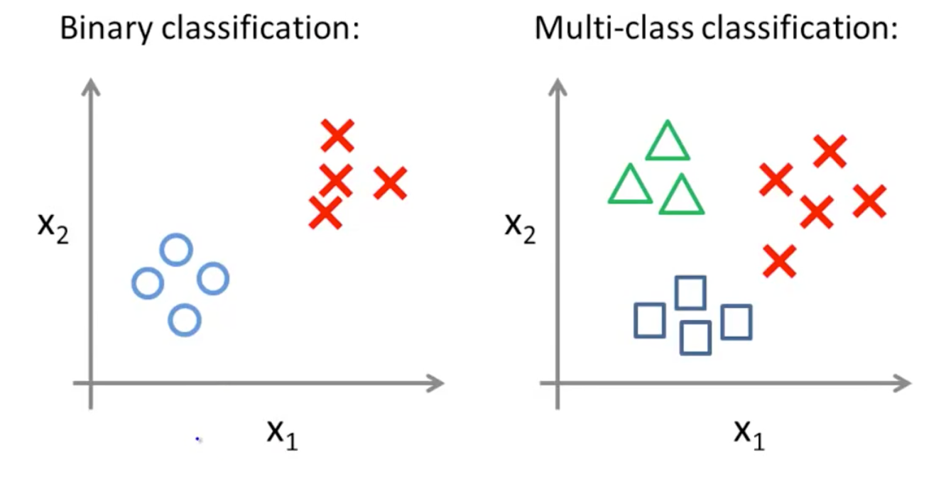
Figure 1 Logistic Regression: Binary classification vs Multi-class Classification

4.1.2 Decision Tree
A Decision Tree is a non-parametric, tree-like model that makes decisions through a sequence of hierarchical, recursive splits on the feature space.
- Theoretical Foundation: The algorithm works by selecting the best feature to split the data at each node based on a criterion like Gini Impurity or Information Gain (based on Entropy). The goal is to create subsets of data that are as pure as possible.
- Tree Structure: It consists of a root node (the first split), internal nodes (subsequent decisions), and leaf nodes (the final class predictions).
- Applicability to this Project: Decision Trees are highly interpretable and mirror human decision-making processes (e.g., "If rainfall is high and temperature is low, then consider crop X"). They can capture non-linear relationships between features and the target variable, which is often the case in agricultural systems.

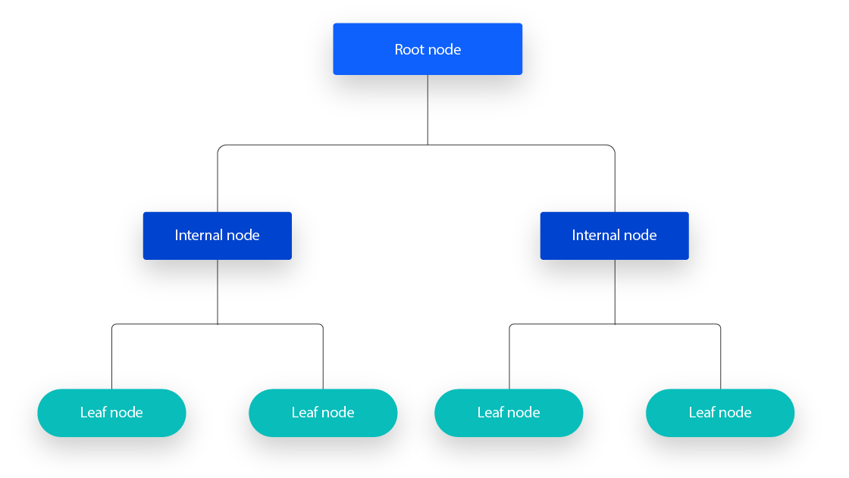
Figure 2 Decision Tree Architecture

4.1.3 Random Forest
Random Forest is an ensemble learning method that operates by constructing a multitude of Decision Trees at training time and outputting the mode of the classes of the individual trees.
- Theoretical Foundation: It is based on the concept of "Bagging" and introduces an additional layer of randomness.
  - Bootstrap Sampling: Multiple random subsets are drawn from the training data (with replacement).
  - Feature Randomness: For each split in every tree, a random subset of features is considered. These splits de-correlates the trees.
  - Aggregation: The predictions from all trees are aggregated, and the final prediction is determined by a majority vote.
- Reduces Overfitting: By averaging the results of many trees, it mitigates the high variance of a single Decision Tree.
- Improves Generalization: Typically achieves higher accuracy and is more robust to noise.
- Provides Feature Importance: Can rank input features based on their contribution to the model's predictions.
- Applicability to this Project: Random Forest is well-suited for this dataset as it is a powerful, general-purpose algorithm capable of modelling complex interactions between soil and climatic factors.
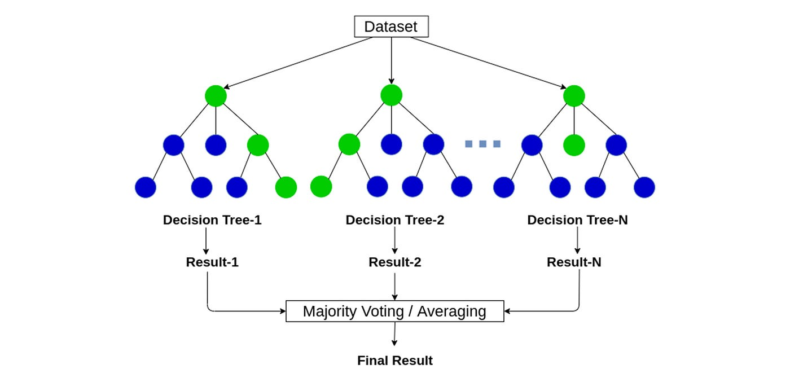
Figure 3 Random Forest Architecture

4.1.4 Rationale behind algorithms selection
The selection of Logistic Regression, Decision Tree, and Random Forest for this study was a deliberate choice based on a multi-faceted rationale encompassing computational efficiency, interpretability, and the specific characteristics of the dataset. This triad of models provides a robust framework for a comparative analysis that is both comprehensive and grounded in practical considerations.

While other algorithms like Support Vector Machines (SVM) and K-Nearest Neighbors (KNN) are valid for classification tasks, they were excluded for specific reasons:
- SVM: Can become computationally intensive with larger datasets and its performance is highly sensitive to the choice of kernel and hyperparameters. The interpretability of SVM models is also lower compared to tree-based methods.

- K-Nearest Neighbors (KNN): KNN is an instance-based learner that suffers from high computational cost during prediction as the dataset grows. It is also very sensitive to the scale of the features and the choice of k, and its performance can degrade with high-dimensional data, despite our dataset having only 7 features.

- Deep Learning/Neural Networks: Were considered but deemed unnecessarily complex for this problem. Given the structured, tabular nature of the data and the modest dataset size (2,200 instances), deep learning models would be highly susceptible to overfitting without extensive regularization and would act as a "black box," offering little of the interpretability that tree-based models provide. The marginal potential gain in accuracy would not justify the loss of transparency and the significant increase in computational and tuning complexity.

In summary, the selected models form a logical and efficient progression from a simple linear baseline (Logistic Regression) to a complex but interpretable non-linear model (Decision Tree), and finally to a powerful, robust ensemble method (Random Forest). This selection ensures a thorough investigation of the problem space while balancing performance, interpretability, and computational practicality.

4.2 Model Evaluation Metrics
To compare the performance of the algorithms objectively, the following standard classification metrics were used.
- Accuracy: The ratio of correctly predicted instances (both true positives and true negatives) to the total instances. It provides a general overview of model performance.
- Precision: The ratio of correctly predicted positive observations to the total predicted positives.
- Recall (Sensitivity): The ratio of correctly predicted positive observations to all actual positives.
- F1-Score: The harmonic mean of Precision and Recall. It is a single metric that balances both concerns, especially useful when class distribution is uneven.
- Classification Report: It is used to assess the model's effectiveness beyond just overall accuracy, giving insight into how well it performs on individual categories.
- Confusion Matrix: A tabular visualization that shows the actual vs. predicted class labels, allowing for a detailed analysis of where the model is confusing one class for another.

4.3 Technologies and Tools
A modern, open-source Python-based stack was selected for its robust libraries, strong community support, and suitability for rapid prototyping and research.
- Programming Language: Python 3.10 was chosen as the primary language due to its extensive ecosystem of data science and machine learning libraries, simplicity, and readability.
- Core Libraries and Frameworks:
- Pandas & NumPy: Employed for all data manipulation, cleaning, and numerical computations.
- Scikit-learn (sklearn): Employed for data preprocessing, implementing all three algorithms, hyperparameter tuning, and model evaluation.
- Matplotlib & Seaborn: Employed for creating all static visualizations, including plots for EDA, confusion matrices, and performance metric charts.
- Joblib: Employed explicitly for saving the trained model to disk and loading it later for making predictions in the Gradio web application, without the need for retraining.
- Gradio: A Python library that allows for the rapid creation of web-based graphical interfaces for machine learning models.
- Development Environment: The entire project was developed in Google Colab Notebook.

4.4 Structure of the dataset
The dataset contains the following attributes:
- Rows (observations): 2,200
- Columns (features + label): 8
- Target variable: label (crop name)
- Number of unique crops: 22
The target class includes diverse crops such as rice, maize, kidney beans, black gram, apple, etc. The presence of both food and cash crops ensures the dataset covers a wide spectrum of agricultural production relevant to Indian farming systems.

4.4.1 Features and Their Agricultural Relevance
The dataset includes seven independent features each directly linked to soil fertility or environmental suitability:
- Nitrogen (N): A macronutrient essential for vegetative growth. Adequate nitrogen promotes chlorophyll synthesis and leaf development.
- Phosphorus (P): Crucial for root development and flowering. Phosphorus deficiencies reduce grain and fruit formation, making this nutrient a strong determinant of yield potential.
- Potassium (K): Plays a key role in osmotic regulation, water use efficiency, and disease resistance. Adequate potassium improves crop resilience under stress conditions such as drought.
- Temperature (°C): Governs germination, growth rate, and flowering cycles. Each crop has a thermal optimum for example, rice grows well in warm humid conditions, while wheat requires cooler temperatures.
- Humidity (%): Relative humidity impacts transpiration, pest pressure, and disease incidence. Crops such as banana and rice thrive in high humidity, whereas pulses prefer moderately dry conditions.
- Soil pH: Affects nutrient solubility and microbial activity. Most crops prefer a pH range of 6–7.5, though certain crops like potato and tea tolerate acidic soils.
- Rainfall (mm): Determines water availability for growth. Rice is water-intensive and requires >1200 mm annual rainfall, whereas pulses such as chickpea and pigeon pea are adapted to semi-arid conditions.
The target label is the recommended crop. By learning the relationship between soil-climatic
variables and crops, machine learning algorithms can predict the most suitable crop for given conditions.

4.4.2 Suitability for the Project
The dataset is particularly suitable for this MSc project for several reasons:
- Relevance to Indian Agriculture: It includes crops widely cultivated across India, making recommendations contextually appropriate.
- Integration of Soil and Climate Variables: By combining macronutrients (Nitrogen, Phosphorus, and Potassium) with environmental features (temperature, rainfall, humidity, pH), it reflects the multi-dimensional factors affecting crop choice.
- Balanced Class Distribution: Ensures fair evaluation of ML algorithms, as no crop dominates disproportionately.
- Scalability for Comparative Analysis: With 2,200 samples and diverse crops, the dataset allows meaningful training and testing of multiple ML models.

4.5 Exploratory Data Analysis (EDA)
A comprehensive Exploratory Data Analysis was conducted to gain an in-depth understanding of the behaviour, variability, and descriptive structure of the seven soil-climatic features in the Crop Recommendation Dataset. Each plot produced in the notebook was examined closely to extract meaningful agricultural insights and identify the inherent patterns that differentiate the 22 crop classes.

4.5.1 Dataset Integrity and Structure
A quality assessment showed no missing values or duplicate records. Descriptive statistics further indicated that all features fall within agriculturally realistic range. These characteristics confirm that the dataset captures a diverse set of soil and climatic conditions reflective of Indian agroecological variability.

Feature | Mean | Standard Deviation | Min | 25% | 50% | 75% | Max
Nitrogen | 50.55 | 36.91 | 0.00 | 21.00 | 37.00 | 84.25 | 140.00
Phosphorous | 53.36 | 32.98 | 5.00 | 28.00 | 51.00 | 68.00 | 145.00
Potassium | 48.14 | 50.64 | 5.00 | 20.00 | 32.00 | 49.00 | 205.00
Temperature | 25.61 | 05.06 | 8.82 | 22.76 | 25.59 | 28.56 | 43.67
Humidity | 71.48 | 22.26 | 14.25 | 60.26 | 80.47 | 89.94 | 99.98
Ph | 6.46 | 0.77 | 3.50 | 5.97 | 6.42 | 6.92 | 9.93
Rainfall | 103.46 | 54.95 | 20.21 | 64.55 | 94.86 | 124.26 | 298.56
Table 2 Statistical summary of the Dataset

4.5.2 Target Variable Distribution
The target variable displays a perfectly uniform distribution, with each of the 22 crop classes represented by exactly 100 instances. The class distribution plot confirms that no crop dominates the dataset, ensuring complete balance across categories. This uniformity means that subsequent analyses of crop relationships are not biased by unequal sample sizes, allowing model performance and variable influence to be evaluated without class imbalance concerns.
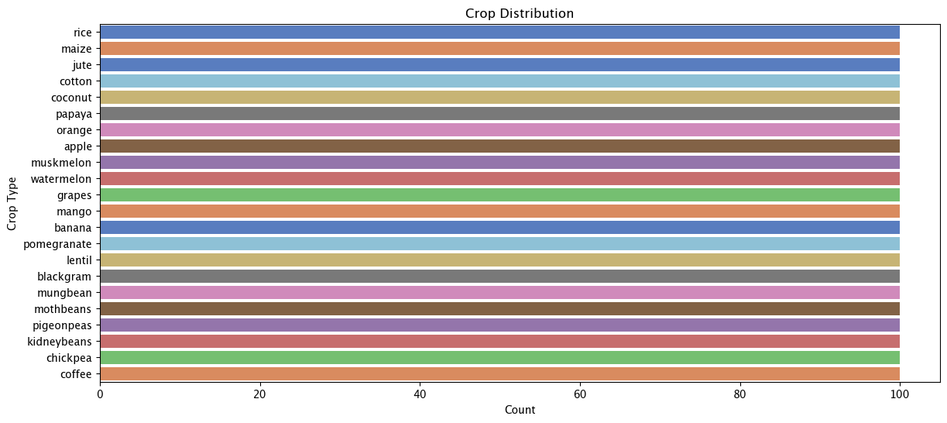
Figure 4 Distribution of the crops

4.5.3 Univariate Feature Distributions and Outlier Assessment
Each of the seven continuous features was examined through paired histogram with KDE plots and boxplots. These collectively reveal the internal structure, shape, and spread of each variable, offering insights into soil nutrient variability and environmental patterns across crop conditions.

Nitrogen (N)
The nitrogen histogram shows a clear multimodal distribution, with major clusters between 0–40 and 70–110, indicating the presence of two distinct nitrogen regimes within the dataset. These patterns likely reflect varying soil fertility levels or differences in fertilisation practices.
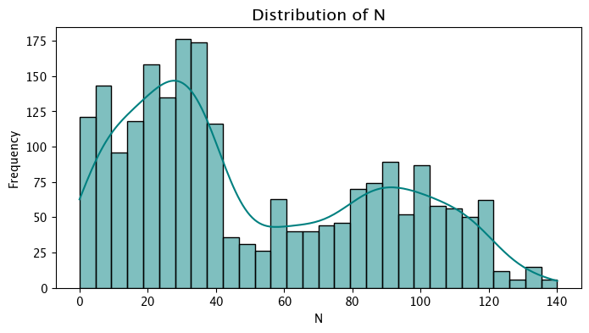
Figure 5 Histogram/KDE plot of Nitrogen

The boxplot reveals a broad spread of nitrogen values, ranging from near zero to around 140, with no extreme outliers and a wide interquartile range. This confirms substantial variability in nitrogen conditions across the samples.
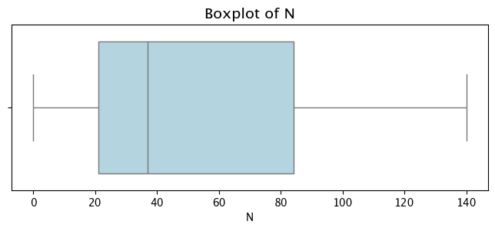
Figure 6 Boxplot of Nitrogen

Phosphorus (P)
Phosphorus displays a primarily unimodal distribution, with most values falling between 20 and 70 and peaking around the 60s. The histogram and KDE curve indicate a gradual decline beyond this range but show a small secondary cluster between roughly 120 and 145, suggesting a minority of samples with notably higher phosphorus levels.
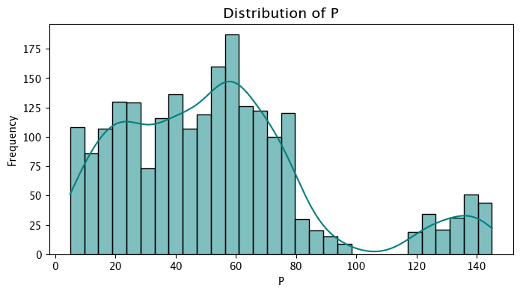
Figure 7 Histogram/KDE plot of Phosphorus

The boxplot showing a wide interquartile range in the mid-values and a long right whisker extending towards the upper extremes. Several mild high-end outliers appear near the whisker tip, indicating elevated phosphorus conditions in a small subset of observations. Overall, the plots show that while phosphorus is generally concentrated in a moderate range, the dataset also captures a distinct group of high-phosphorus samples.
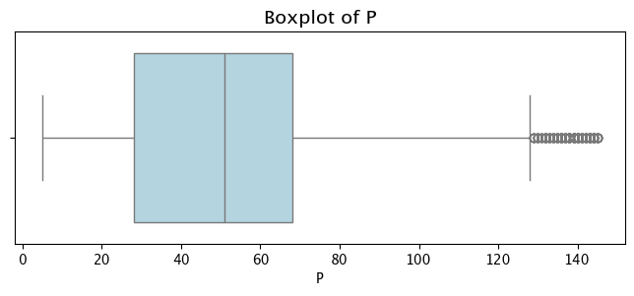
Figure 8 Boxplot of Phosphorus
Potassium (K)
Potassium shows a highly skewed and discontinuous distribution. Most values lie between 10 and 60, forming the dominant cluster in the histogram, while frequencies drop sharply beyond this range. A small but distinct second cluster appears around 190–210, creating a clear separation between typical and high-potassium conditions.
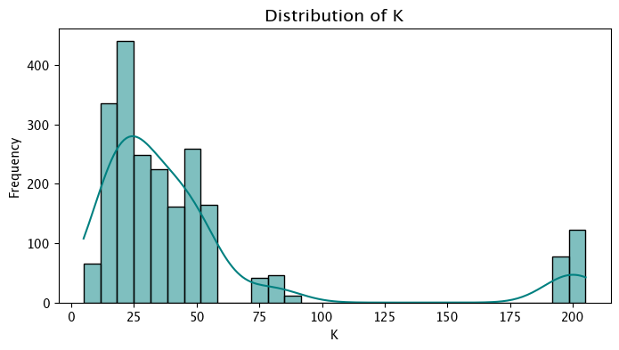
Figure 9 Histogram/KDE plot of Potassium

The boxplot shows that the interquartile range is concentrated in the lower band, while a long right whisker and several outliers near 200 indicate a minority of samples with substantially elevated potassium. These points represent a genuine high-potassium regime rather than anomalies. Overall, potassium spans a wide range but is dominated by low-to-moderate values, with a small cluster of notably high concentrations.
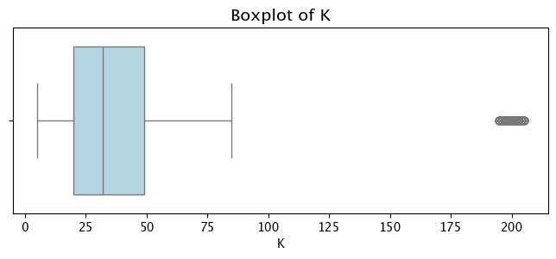
Figure 10 Boxplot of Potassium

Temperature
Temperature displays an approximately bell-shaped distribution, with most observations concentrated between 20°C and 30°C and a clear peak around 25°-27°C. The histogram and KDE curve show symmetrical tapering on both sides, with relatively few samples below 15°C or above 40°C, indicating limited representation of extreme conditions.
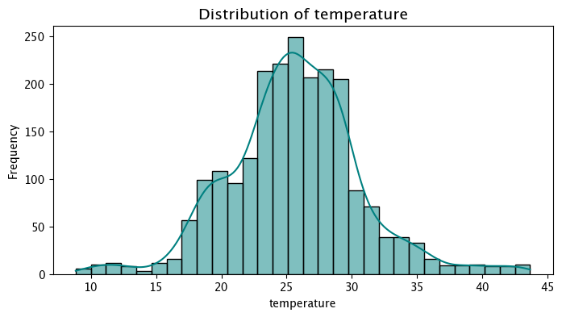
Figure 11 Histogram/KDE plot of Temperature

The boxplot showing a compact interquartile range centred in the mid-20s and whiskers extending into cooler and warmer ranges. A few mild outliers appear at both ends but do not indicate irregularities. Overall, the temperature data reflects predominantly warm, typical growing conditions, with only a small portion of samples representing unusually cool or hot environments.
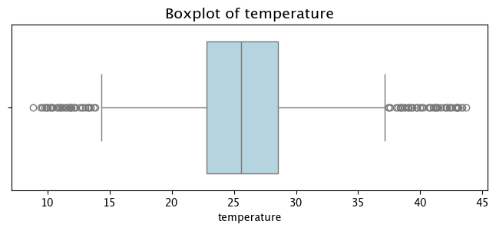
Figure 12 Boxplot of Temperature

Humidity
Humidity exhibits a distinctly multimodal distribution, reflecting several environmental regimes within the dataset. A small group of values appears in the lower range (10-25), followed by a sparse mid-range and a larger band between 40 and 70. The dominant cluster lies in the upper range (80-95), forming the main peak in both the histogram and KDE curve.
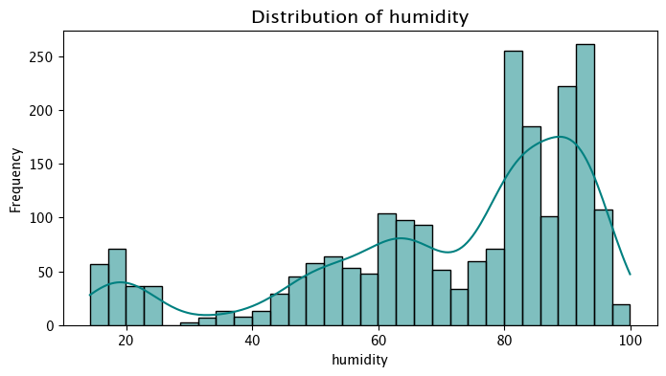
Figure 13 Histogram/KDE plot of Humidity

The boxplot confirms this variability, with a wide interquartile range covering the 60 to 90 and whiskers extending toward both low and near-saturated humidity levels. A few low-humidity points appear as mild outliers but represent legitimate environmental cases. Overall, the plots illustrate that humidity in the dataset is diverse, with a strong emphasis on moderately high to very high humidity conditions.
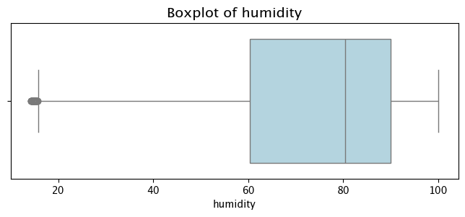
Figure 14 Boxplot of Humidity
pH
The pH distribution follows a smooth, bell-shaped pattern, with most observations lying between 5.5 and 7.5 and a clear peak around 6.5. The histogram and KDE curve show gradual declines on both sides, indicating that strongly acidic (<5) and alkaline (>8.5) soils appear only infrequently. A few observations occur near pH 3.5 and 9.5, demonstrating limited but valid representation of extreme soil reactions.
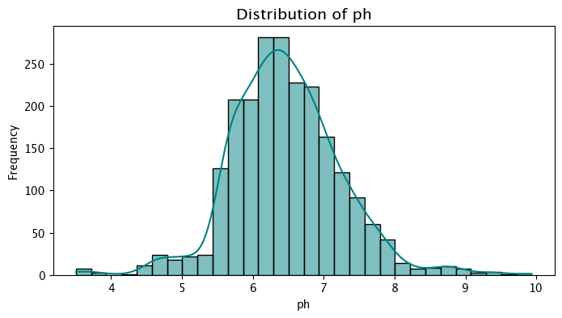
Figure 15 Histogram/KDE plot of pH

The boxplot supports this, with an interquartile range spanning roughly pH 6-7 and whiskers extending toward both acidic and alkaline conditions. Several mild outliers appear beyond the whiskers. Overall, the plots show that pH in the dataset is centred around moderately acidic to neutral conditions but includes a meaningful range of soil reactions relevant to diverse crop types.
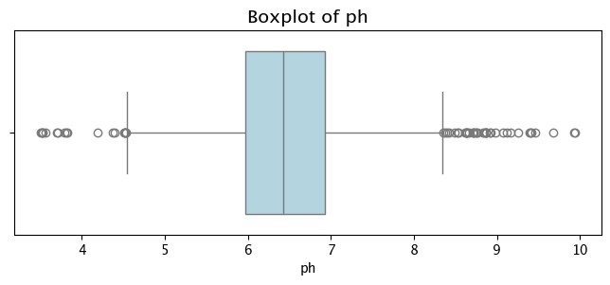
Figure 16 Boxplot of pH
Rainfall
Rainfall exhibits a broad, moderately multimodal distribution. Most values fall between 60 mm and 130 mm, forming the main body of the histogram with smaller peaks around 60 and 100mm. A secondary concentration appears between 150 mm and 200 mm, while frequencies gradually taper toward the upper extreme near 300 mm. The KDE curve reflects these multiple clusters, indicating diverse rainfall regimes within the dataset.
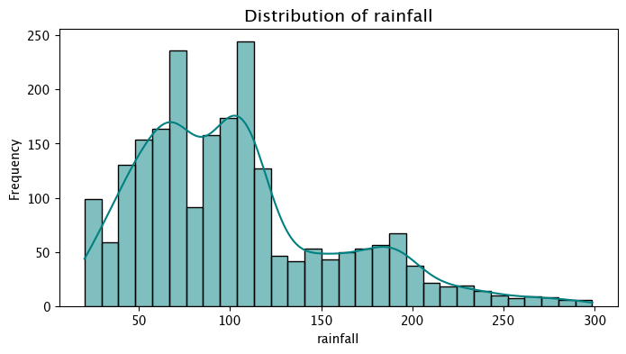
Figure 17 Histogram/KDE plot of Rainfall

The boxplot shows a wide interquartile range extending through moderate to high rainfall values. The upper whisker reaches approximately 210 mm, beyond which many points appear as outliers, these form a dense cluster, suggesting that high-rainfall conditions are less common but well represented. Overall, the dataset encompasses substantial rainfall variability, dominated by moderate conditions with meaningful representation of both low and high extremes.
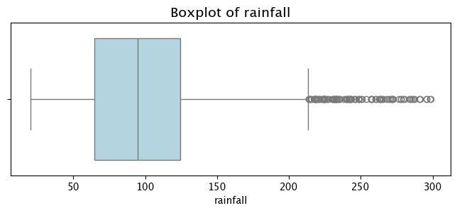
Figure 18 Boxplot of Rainfall

4.5.4 Feature vs Target Relationship
Nitrogen levels across crops
The nitrogen distribution across crops shows clear nutrient-based differentiation. High- Nitrogen crops such as cotton, coffee, banana, and watermelon occupy the upper range with tightly grouped medians, while legumes including Chickpea, kidney beans, and lentil cluster in the lowest ranges, reflecting their nitrogen-fixing nature. Mid-range crops such as rice, maize, and papaya sit between these extremes. This structured separation demonstrates that nitrogen provides strong class discriminability, creating well-defined crop clusters in the dataset.
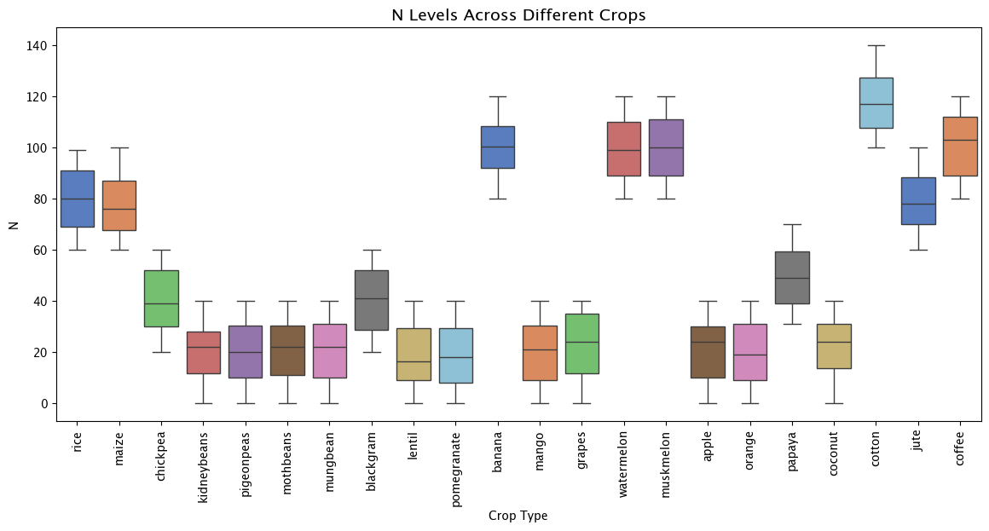
Figure 19 Nitrogen levels across crops
Phosphorus levels across crops
Phosphorus values also form distinct groupings, crops like grapes, and apple show high and consistent phosphorus ranges, while many fruit crops such as watermelon, muskmelon, oranges, and pomegranate fall in low- phosphorus bands. Staple crops including chickpea, lentils, kidney beans, and moth beans occupy moderate levels in between.

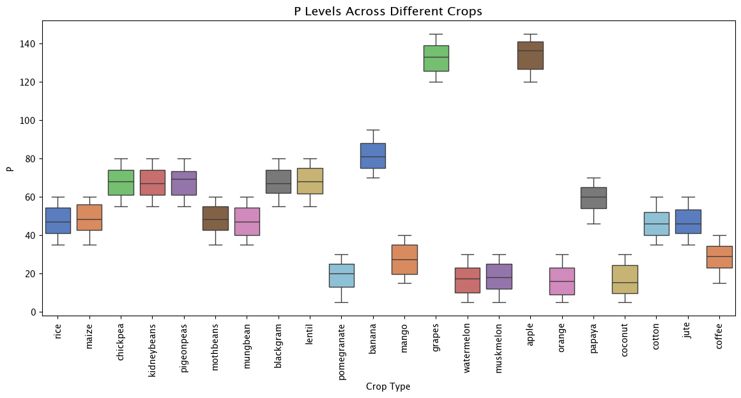
Figure 20 Phosphorous levels across crops
Potassium levels across crops
Potassium exhibits the strongest separability of all nutrients. Most crops cluster in low-to-moderate potassium ranges, but grapes and apple form a unique high- potassium group with values near 200, creating a dramatic outlier segment. Legumes and many fruits sit at the low end, whereas chickpeas fall in moderate bands. This stark contrast makes potassium a highly informative feature for crop classification.

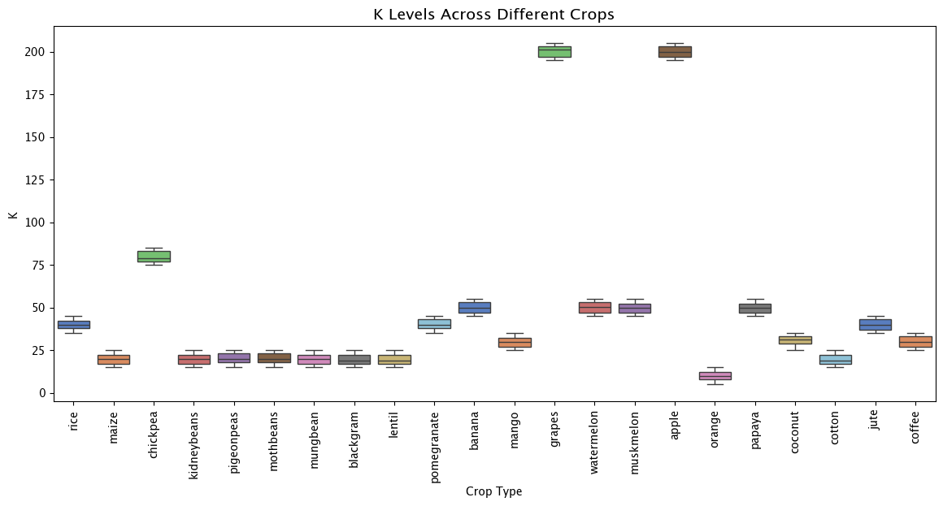
Figure 21 Potassium levels across crops
Temperature levels across crops
Temperature distributions reveal climatic zoning among crops. Tropical crops such as mango and papaya occupy high-temperature ranges, whereas crops like chickpea fall into much lower ranges. Many crops such as rice, maize, cotton and jute occupy a central band around 20°–25°C. These distinctions demonstrate the relevance of thermal conditions in shaping crop suitability.
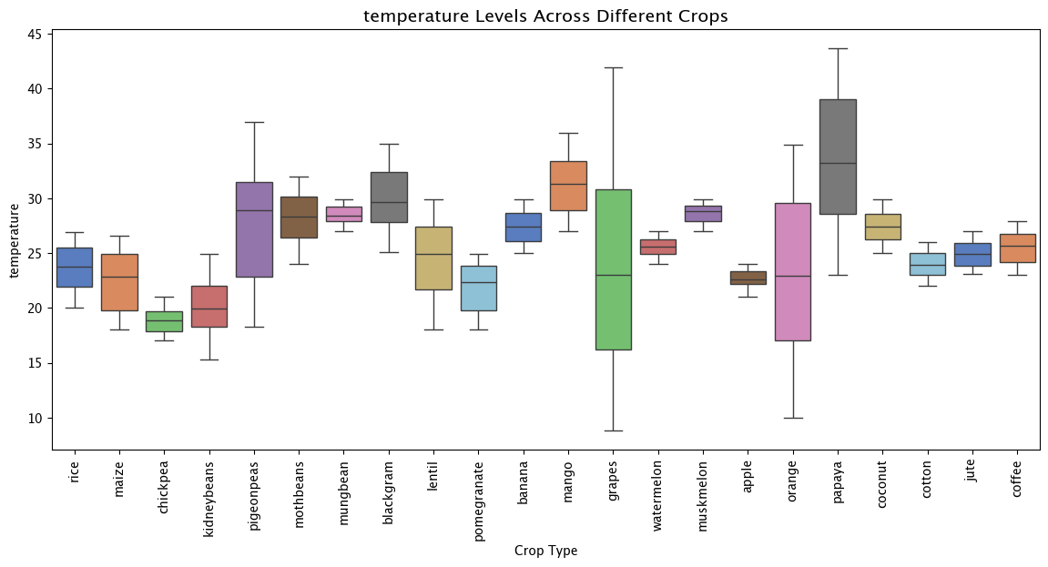
Figure 22 Temperature levels across crops
Humidity levels across crops
Humidity patterns show considerable ecological variation. Dry-region crops such as chickpea and kidney beans show low humidity distributions, contrasting sharply with high-humidity horticultural crops like muskmelon, papaya, and coconut. A mid-range cluster includes lentils, maize and black gram. The wide humidity spread captures diverse agroclimatic environments, reinforcing its importance as a separating feature.

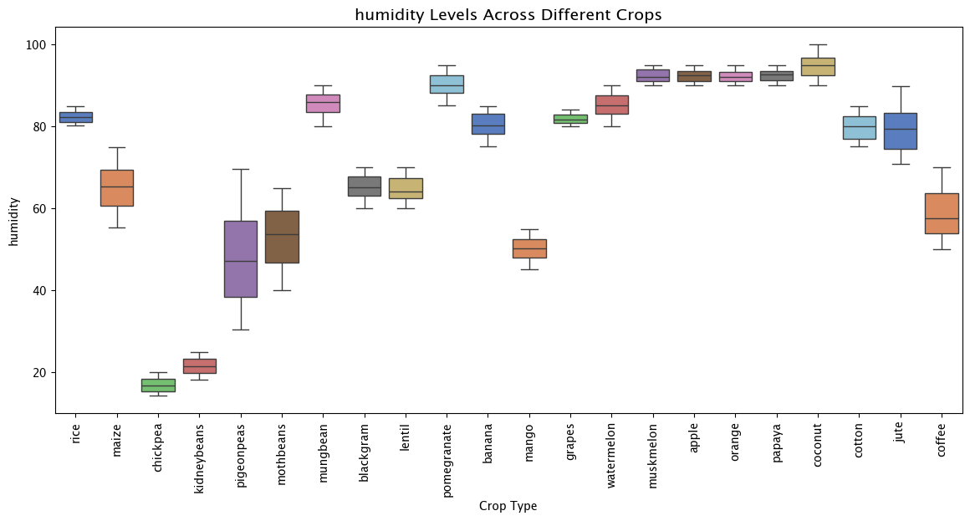
Figure 23 Humidity levels across crops
Soil pH levels across crops
Soil pH values fall mostly within moderately acidic to neutral ranges, but crop-specific patterns remain visible. Legumes tend toward slightly acidic soils, while crops like orange, cotton, and coffee forming a cluster near neutral pH. A few crops, such as moth beans, chickpea and rice occupy wider ranges, indicating broader soil adaptability. Although pH is less discriminative than nitrogen or potassium, it still contributes meaningful variation.

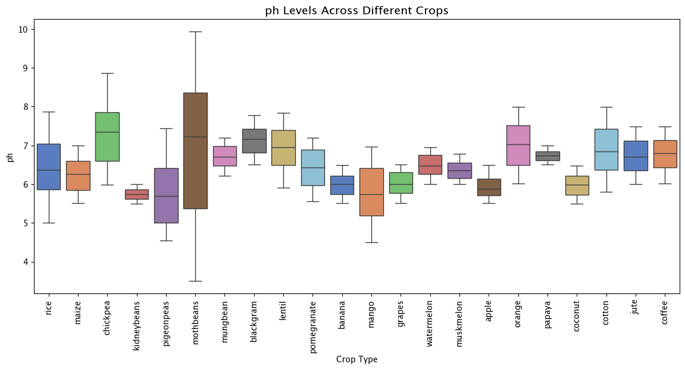
Figure 24 pH levels across crops
Rainfall levels across crops
Rainfall distributions show strong climatic signatures. High-rainfall crops including rice, coconut, and papaya form distinct upper range bands, whereas muskmelon, and lentil occupy consistently low rainfall levels. Many crops fall in intermediate rainfall conditions around 80-150 mm. The presence of both low and extremely high rainfall classes highlights rainfall’s role as a key driver of crop separation.
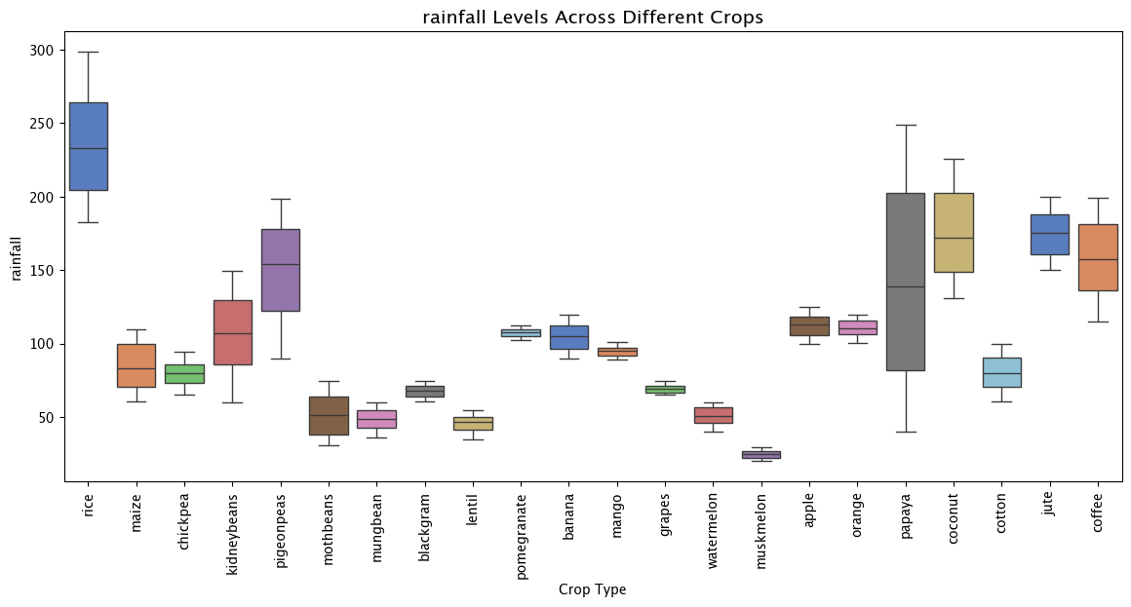
Figure 25 Rainfall levels across crops

4.5.5 Heatmap of Average Feature Values per Crop
The heatmap offers a consolidated view of mean soil and climatic conditions for each crop, revealing clear nutrient and environmental signatures. Nitrogen shows strong separation between crop groups such as banana, cotton, coffee and muskmelon exhibit high average nitrogen values, whereas legumes such as mung bean, lentil and kidney beans consistently appear in the lowest range.
Similar contrasts are visible for phosphorus, with apple and grapes showing high average values, while orange, muskmelon and coconut lie at the lower end.

Potassium displays the most pronounced variation, with grapes and apple showing exceptionally high K averages (near 200), far exceeding all other crops.

Temperature varies moderately across crops, with mango, papaya, and black gram linked to warmer conditions, and legumes and apple associated with cooler environments.

Humidity is highest for crops such as orange, muskmelon and papaya, and lowest for legumes including pigeon peas and moth beans.

Rainfall forms another clear gradient rice, jute and coconut have high average rainfall, whereas muskmelon and watermelon appear in the drier categories.

Overall, the heatmap demonstrates well-defined clusters of crops sharing similar soil nutrient and climatic profiles, confirming distinct agroecological patterns within the dataset.

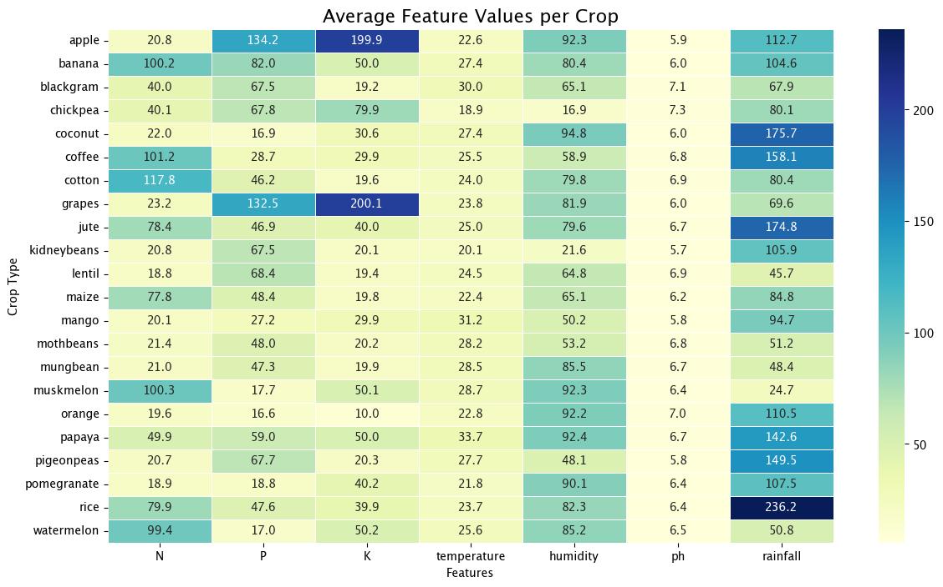
Figure 26 Average feature values per crop

4.5.6 Feature Correlation Heatmap
The correlation heatmap shows that most numerical features exhibit very weak linear relationships, with coefficients clustered near zero. This indicates that the variables capture largely independent soil and climatic characteristics. The only strong association is the positive correlation between phosphorus and potassium (r ≈ 0.74), suggesting that high phosphorus soils tend to also have elevated potassium levels, potentially reflecting shared fertility conditions or similar nutrient management practices.
Other correlations remain minimal, nitrogen shows weak negative relationships with phosphorous and potassium and a slight positive association with humidity, while rainfall, temperature, pH and humidity display similarly low coefficients across the matrix. Overall, the heatmap confirms the absence of multicollinearity and supports the use of all seven features as distinct predictors in subsequent modelling.
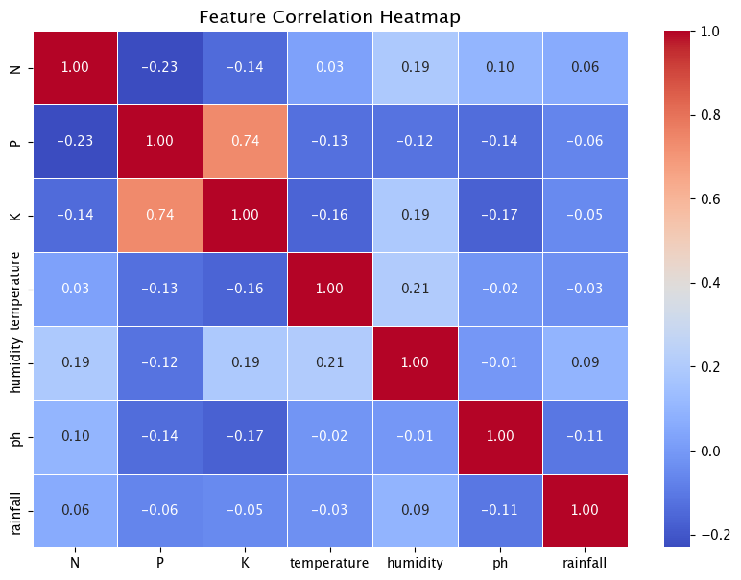
Figure 27 Feature correlation heatmap

4.6 Data Preprocessing and Model Development
Following the exploratory analysis, the dataset was prepared for model training through a structured preprocessing and validation procedure. The original data consisted of seven numerical predictor variables and a categorical target variable representing 22 crop classes. To separate the predictors from the target, the label column was extracted, leaving the remaining variables as the input feature matrix.

4.6.1 Train-Test Split and Feature Preparation
The dataset was split into training and test subsets using an 80/20 ratio and a fixed random seed to maintain reproducibility. All seven numerical features were retained without transformation except for models that required scaling. Logistic Regression was paired with standardisation, whereas Decision Tree and Random Forest were applied directly to the raw numeric features.

4.6.2 Pipeline Construction and Baseline Modelling
Model pipelines were constructed for each classifier, encapsulating the necessary preprocessing steps and the classifier itself. Pipelines ensured consistent processing across training, validation, and testing phases while simplifying hyperparameter tuning. Baseline models were first trained with default parameter configurations to establish initial performance benchmarks.

4.6.3 Testing Strategy
The testing strategy was planned in three layers:
- Baseline testing: Each model’s initial performance was assessed on both training and test data to establish early indicators of accuracy, robustness, and potential overfitting.
- Cross-validation testing: During hyperparameter tuning, five-fold cross-validation was used to assess model performance on multiple subsets of the training data. This allowed evaluation across several partitions, reducing reliance on any single split.
- Final system testing: The tuned models were evaluated on the held-out test set. Confusion matrices, classification reports, and performance metrics were used to evaluate not only overall performance but also class-specific behaviour.
For the Gradio application, manual functional testing was performed to assess the correctness of user input handling, validation messages, and prediction responses. This ensured that the deployed interface consistently returned correct outputs and gracefully handled incorrect or incomplete inputs.

4.6.4 Hyperparameter Tuning
Systematic hyperparameter optimisation was conducted using grid search with five-fold cross-validation. Different hyperparameters were explored depending on the model class, including:
- Regularisation strength for Logistic Regression.
- Maximum depth and node constraints for Decision Tree.
- Depth, sampling strategy, and leaf constraints for Random Forest.
The weighted F1-score served as the optimisation metric to ensure balanced evaluation across all classes. The best-performing combination identified through cross-validation was selected as the final model for each algorithm.

4.6.5 Validation
Model validation occurred at multiple levels. The use of a held-out test set provided an unbiased estimate of performance. Cross-validation ensured that the model’s behaviour was stable across multiple resampled partitions of the data, reducing the risk of variance-driven misinterpretation.
Finally, confusion matrices enabled validation of prediction consistency across all twenty-two crop classes, allowing inspection of class-level reliability rather than purely aggregate performance.

4.6.6 Model Persistence
The tuned models were serialised using Joblib, enabling them to be reloaded without retraining. This ensured that the same optimised models evaluated during experimentation were used directly in the deployed application, preserving consistency across development and deployment stages.

4.7 Gradio-Based Web Application for Crop Recommendation
To make the trained machine learning model accessible to end users, a lightweight web application was developed using the Gradio framework. Gradio enables rapid development of web interface, allowing users to input soil and climatic parameters and receive an instant crop recommendation from the tuned Random Forest model.

The application loads the final optimised Random Forest classifier at startup, ensuring consistency between offline evaluation and real-time inference without the need for retraining. Users provide seven numerical inputs, which directly correspond to the features used during model training.

Basic input validation ensures that missing values trigger immediate warnings, preventing incomplete submissions. Once all parameters are supplied, the inputs are assembled into a structured format and passed to the model, which returns the predicted crop label for display in the output box. The interface also includes a brief title and description to support usability.
Overall, the Gradio application effectively bridges model development and practical deployment by providing a simple, accessible platform for real-time crop prediction through any standard web browser.

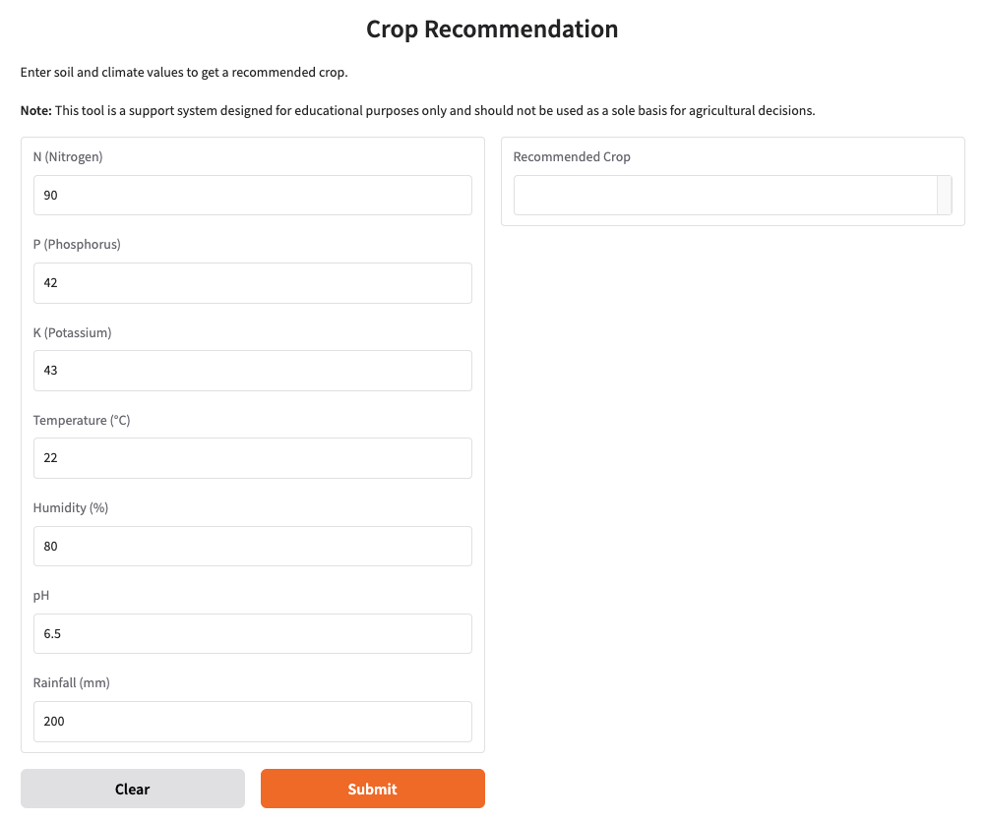
Figure 28 Web Application Interface

4.8 Ethical, Legal, Social, and Professional Issues
Although the current prototype does not process personal data, several ethical, legal, social and professional considerations become relevant for real-world deployment of a crop recommendation system.

4.8.1 Ethical Considerations
A key ethical concern is the reliability of predictions, as incorrect recommendations could result in financial loss or crop failure, especially for smallholder farmers. The system must therefore be rigorously validated and clearly presented as a decision-support tool rather than a definitive expert system. Dataset representativeness is another issue, the Kaggle dataset does not capture the full diversity of Indian soil and climatic conditions, raising the risk of biased or regionally unsuitable recommendations. Future deployment would require regional calibration and transparency about data limitations.

4.8.2 Legal Considerations
The prototype does not fall under data protection regulations such as GDPR because it stores no personal information. However, future versions incorporating user profiles, GPS data or farm-level records would require compliance with privacy laws, including informed consent, secure storage and transparent data handling practices. Liability is another consideration, if users rely solely on model outputs, accountability questions may arise. Clear disclaimers, usage guidance and positioning the tool as advisory can help mitigate legal risk.

4.8.3 Social Considerations
Digital access varies significantly across rural communities, and the introduction of AI tools may widen existing inequalities. To avoid digital exclusion, future deployments should ensure accessibility across devices, support local languages and include training through agricultural extension services. There is also a risk of over-reliance on algorithmic outputs, which may marginalise traditional knowledge. The system should be used to complement, rather than replace, local expertise and human judgement.

4.8.4 Professional Considerations
Developing and deploying an agricultural decision-support tool requires adherence to professional standards in software engineering and AI ethics. This includes rigorous testing, reproducibility, version control and transparent documentation. Developers must avoid overstating the system’s capabilities and ensure that outputs are communicated clearly to non-experts. If scaled into an operational product, ongoing audits, model monitoring and periodic retraining will be essential to maintain accuracy, fairness and professional integrity.

4.8.5 Risk Management and Mitigation
To manage the risks associated with these ethical, legal, social, and professional issues, several measures can be implemented.
- Transparency and Disclaimers: Clearly state that the system is a decision-support tool and should not be used as the sole basis for agricultural decisions.
- Dataset Expansion: Continuously expand and refine the dataset with region-specific and up-to-date samples to reduce bias and improve model reliability.
- User Education: Provide simple guidelines, tutorials, or advisory notes to help users interpret outputs correctly and understand limitations.
- Data Governance: If user data is incorporated in future versions, ensure compliance with GDPR or equivalent regulations, including secure storage and explicit consent mechanisms.
- Fair Access: Develop interface versions that accommodate low literacy levels, local languages, and varying device capabilities to promote equitable adoption.
- Monitoring and Feedback: Allow users or agricultural officers to report issues or inaccuracies, enabling iterative improvements to the model.
- Sustainable Design: Consider environmental metrics or sustainability constraints in future iterations of the recommendation system.

4.9 GitHub Repository and Source Code Availability
All source code, trained model files and the dataset used in this project are hosted in a dedicated GitHub repository to ensure transparency and reproducibility. The repository contains the complete implementation pipeline, including exploratory data analysis, preprocessing, model training, hyperparameter tuning and the Gradio application code. Tuned models are provided as joblib files, allowing users to load and evaluate the exact versions used in the dissertation.

The dataset is included in its original CSV format, and the repository follows a clear folder structure for easy navigation. A comprehensive README file outlines installation steps, dependencies and instructions for running both the training workflow and the deployed interface. By making all project components openly accessible, the repository supports good research practice and enables future users to replicate, extend or adapt the system.

GitHub Repository: https://github.com/AyishaSherinPilakkal/crop-recommendation-using-machine-learning

4.10 Practicality, Challenges, and Limitations
Although the implementation was successful, several practical constraints shaped the methodology. The dataset, while clean and balanced, represents idealised soil-climate conditions and does not capture real-world variability such as microclimate shifts, soil heterogeneity or differing cultivation practices. As a result, the model would require region-specific calibration before practical deployment.
Computational factors also influenced methodological choices. Deployment considerations were similarly constrained, the Gradio interface relies on manual input and local execution, whereas real agricultural use would require integration with sensors or mobile data collection systems.
These limitations were addressed through reproducible pipelines, efficient tooling, controlled parameter searches and detailed documentation.

5. Quality and Results

5.1 Overview
This chapter presents the performance outcomes of the three machine learning models implemented in this study. Results are evaluated using accuracy, F1-score, classification reports and confusion matrices. Beyond reporting metrics, the chapter critically analyses model behaviour, compares tuned and baseline models, links findings to the literature and project objectives, and reflects on practical challenges and implications for real-world crop recommendation.

5.2 Baseline Model Performance
The baseline models established initial predictive performance using standard hyperparameters. All three algorithms performed strongly on the test set, supported by the balanced and well-structured nature of the dataset.

Model | Train Accuracy (%) | Test Accuracy (%) | Test F1-Score (%)
Logistic Regression | 97.78 | 96.36 | 96.35
Decision Tree | 100 | 98.63 | 98.63
Random Forest | 1.00 | 99.31 | 99.31
Table 3 Baseline model performance overview

Logistic Regression delivered good baseline accuracy despite its linear nature, suggesting that several crop classes have reasonably linear separability. The Decision Tree perfectly memorised the training set with 100% accuracy, displaying classic overfitting behaviour but still generalised better than Logistic Regression. Random Forest achieved the highest baseline test accuracy of 99.31%.

These results align with previous research (e.g., Shastri et al., 2025, and Sani et al., 2023), which consistently reports superior performance of ensemble models on structured agricultural datasets. These initial results address Research Question 1, confirming that classical ML models can accurately predict crop suitability from soil and climatic features, with Random Forest outperforming the others.

5.3 Hyperparameter Tuning and Improved Performance
Hyperparameter tuning was conducted to optimise each model and address overfitting risks. The best parameter configurations identified were:
- Logistic Regression: C = 10
- Decision Tree: max_depth = 15, min_samples_split = 10, min_samples_leaf = 1
- Random Forest: max_depth = 15, max_features = "sqrt", min_samples_split = 2, min_samples_leaf = 1

The tuned model results are summarised below:
Model | Test Accuracy (%) | Test F1-Score (%)
Logistic Regression | 97.04 | 97.03
Decision Tree | 98.18 | 98.18
Random Forest | 99.31 | 99.31
Table 4 Tunned model performance summary
Logistic Regression benefited modestly from increased regularisation strength, improving its accuracy by 0.7%. Decision Tree accuracy dropped slightly after tuning, but the tuned model generalised better and avoided the perfect-fit behaviour seen in training. Random Forest performance remained similar however, tuning enhanced consistency and interpretability by reducing unnecessary model complexity. These improvements demonstrate the value of controlled hyperparameter tuning, directly fulfilling Objective 3.

5.4 Confusion Matrix Analysis
While overall accuracy is high across all models, confusion matrices offer deeper insight into class-specific behaviour and the robustness of predictions.

Logistic Regression
The confusion matrix shows that most crops were correctly classified, but a few classes particularly jute, rice and pigeon peas exhibited occasional misclassifications. These crops share overlapping nutrient and climatic profiles, explaining the model’s difficulty in establishing linear boundaries. Nevertheless, the overall structure remains strongly diagonal, reflecting reliable class separation.

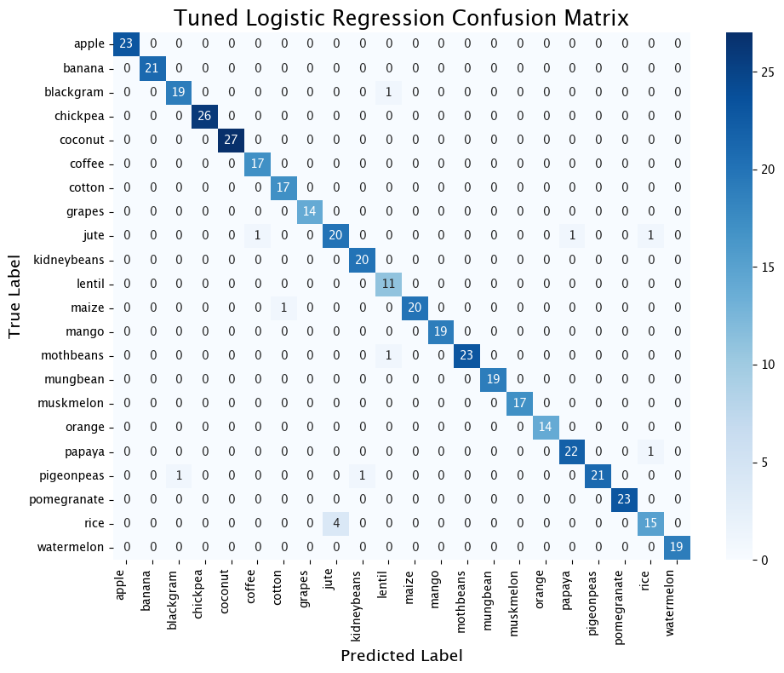
Figure 29 Confusion Matrix of Logistic Regression

Decision Tree
Decision Tree corrected some of Logistic Regression’s errors, especially for legumes and fruit crops. However, isolated misclassifications appeared for jute and rice, consistent with the model’s sensitivity to minor feature fluctuations. Despite this, the tuned Decision Tree achieved nearly perfect recall for most classes, confirming its ability to capture non-linear relationships.

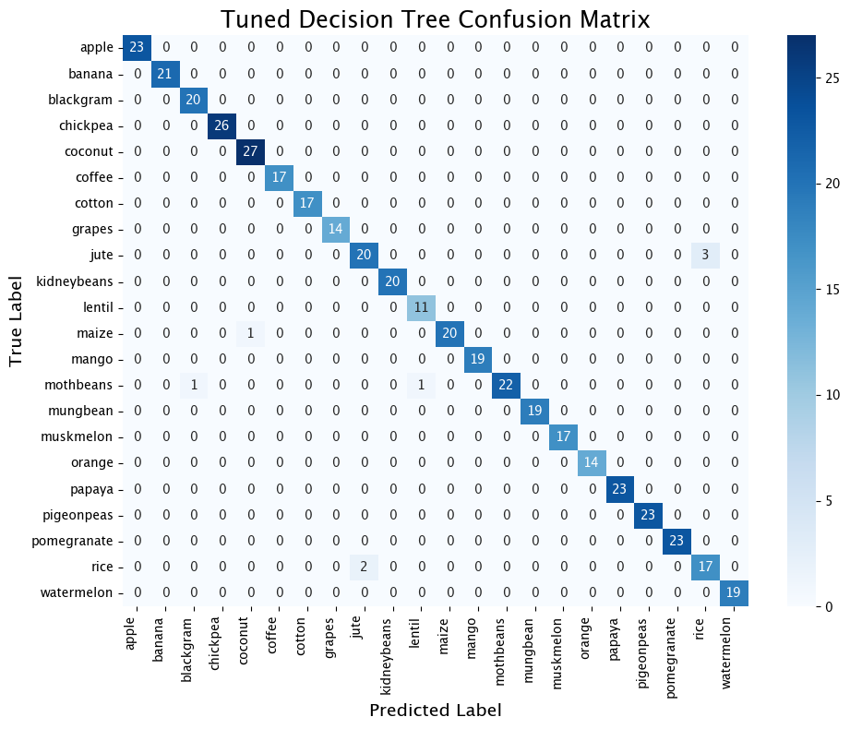
Figure 30 Confusion Matrix of Decision Tree
Random Forest
The Random Forest confusion matrix is almost perfectly diagonal, with only two misclassified samples across all 22 classes. This demonstrates excellent generalisation and class stability, reinforcing why ensemble methods outperform both linear and single-tree models in the literature. This level of performance confirms findings in existing studies (e.g., Disha et al., 2024), which highlight Random Forest as a reliable choice for agricultural classification tasks.

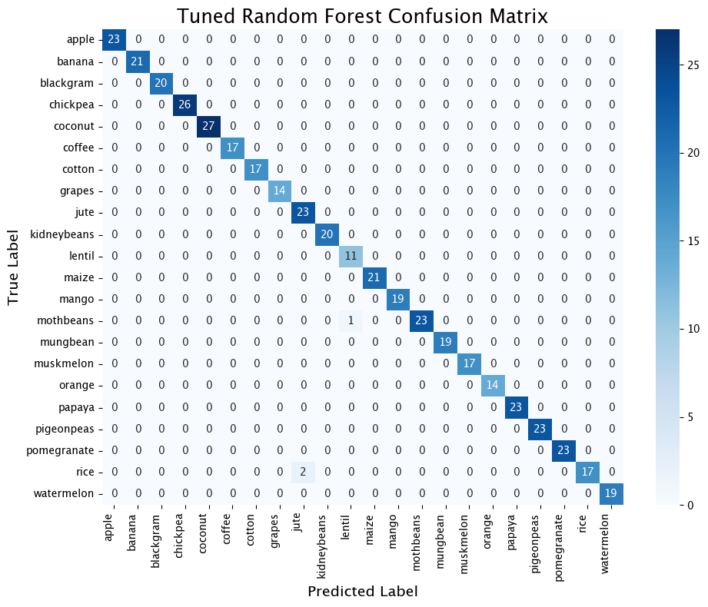
Figure 31 Confusion Matrix of Random Forest

5.5 Classification Report Analysis
The classification reports provide detailed class-wise precision, recall and F1-scores, offering deeper insight into model behaviour beyond accuracy metrics.

Logistic Regression
Logistic Regression achieved strong macro and weighted F1-scores (0.97), with perfect predictions for many fruit and pulse crops. However, performance dipped for classes with overlapping feature profiles. Jute (F1 = 0.85), lentil (F1 = 0.92) and rice (F1 = 0.83) showed lower metrics, primarily due to reduced recall (e.g., rice recall = 0.79). These results highlight the model’s limitations in capturing non-linear boundaries.

Crop | Precision | Recall | F1-score | Support
apple | 1.00 | 1.00 | 1.00 | 23
banana | 1.00 | 1.00 | 1.00 | 21
blackgram | 0.95 | 0.95 | 0.95 | 20
chickpea | 1.00 | 1.00 | 1.00 | 26
coconut | 1.00 | 1.00 | 1.00 | 27
coffee | 0.94 | 1.00 | 0.97 | 17
cotton | 0.94 | 1.00 | 0.97 | 17
grapes | 1.00 | 1.00 | 1.00 | 14
jute | 0.83 | 0.87 | 0.85 | 23
kidneybeans | 0.95 | 1.00 | 0.98 | 20
lentil | 0.85 | 1.00 | 0.92 | 11
maize | 1.00 | 0.95 | 0.98 | 21
mango | 1.00 | 1.00 | 1.00 | 19
mothbeans | 1.00 | 0.96 | 0.98 | 24
mungbean | 1.00 | 1.00 | 1.00 | 19
muskmelon | 1.00 | 1.00 | 1.00 | 17
orange | 1.00 | 1.00 | 1.00 | 14
papaya | 0.96 | 0.96 | 0.96 | 23
pigeonpeas | 1.00 | 0.91 | 0.95 | 23
pomegranate | 1.00 | 1.00 | 1.00 | 23
rice | 0.88 | 0.79 | 0.83 | 19
watermelon | 1.00 | 1.00 | 1.00 | 19
Macro average | 0.97 | 0.97 | 0.97 | 440
Weighted average | 0.97 | 0.97 | 0.97 | 440
Table 5 Classification Report of Logistic Regression
Decision Tree
The tuned Decision Tree produced high macro and weighted F1-scores (0.98). Most crops achieved perfect precision and recall, but moderate reductions remained for jute (F1 = 0.89) and rice (F1 = 0.87). These cases again correspond to crops with overlapping nutrient and rainfall characteristics. While the Decision Tree better accommodates non-linearity, it remains sensitive to local fluctuations.

Crop | Precision | Recall | F1-score | Support
apple | 1.00 | 1.00 | 1.00 | 23
banana | 1.00 | 1.00 | 1.00 | 21
blackgram | 0.95 | 1.00 | 0.98 | 20
chickpea | 1.00 | 1.00 | 1.00 | 26
coconut | 0.96 | 1.00 | 0.98 | 27
coffee | 1.00 | 1.00 | 1.00 | 17
cotton | 1.00 | 1.00 | 1.00 | 17
grapes | 1.00 | 1.00 | 1.00 | 14
jute | 0.91 | 0.87 | 0.89 | 23
kidneybeans | 1.00 | 1.00 | 1.00 | 20
lentil | 0.92 | 1.00 | 0.96 | 11
maize | 1.00 | 0.95 | 0.98 | 21
mango | 1.00 | 1.00 | 1.00 | 19
mothbeans | 1.00 | 0.92 | 0.96 | 24
mungbean | 1.00 | 1.00 | 1.00 | 19
muskmelon | 1.00 | 1.00 | 1.00 | 17
orange | 1.00 | 1.00 | 1.00 | 14
papaya | 1.00 | 1.00 | 1.00 | 23
pigeonpeas | 1.00 | 1.00 | 1.00 | 23
pomegranate | 1.00 | 1.00 | 1.00 | 23
rice | 0.85 | 0.89 | 0.87 | 19
watermelon | 1.00 | 1.00 | 1.00 | 19
Macro average | 0.98 | 0.98 | 0.98 | 440
Weighted average | 0.98 | 0.98 | 0.98 | 440
Table 6 Classification Report of Decision Tree

Random Forest
Random Forest delivered the most consistent per-class metrics, with nearly all crops achieving precision, recall and F1-scores of 1.00. Minor reductions appeared only in rice (F1 = 0.94) and moth beans (F1 = 0.98). These align with the few misclassifications observed in the confusion matrix. Ensemble averaging effectively eliminates variance, producing highly stable predictions across all crop types.

Crop | Precision | Recall | F1-score | Support
apple | 1.00 | 1.00 | 1.00 | 23
banana | 1.00 | 1.00 | 1.00 | 21
blackgram | 1.00 | 1.00 | 1.00 | 20
chickpea | 1.00 | 1.00 | 1.00 | 26
coconut | 1.00 | 1.00 | 1.00 | 27
coffee | 1.00 | 1.00 | 1.00 | 17
cotton | 1.00 | 1.00 | 1.00 | 17
grapes | 1.00 | 1.00 | 1.00 | 14
jute | 0.92 | 1.00 | 0.96 | 23
kidneybeans | 1.00 | 1.00 | 1.00 | 20
lentil | 0.92 | 1.00 | 0.96 | 11
maize | 1.00 | 1.00 | 1.00 | 21
mango | 1.00 | 1.00 | 1.00 | 19
mothbeans | 1.00 | 0.96 | 0.98 | 24
mungbean | 1.00 | 1.00 | 1.00 | 19
muskmelon | 1.00 | 1.00 | 1.00 | 17
orange | 1.00 | 1.00 | 1.00 | 14
papaya | 1.00 | 1.00 | 1.00 | 23
pigeonpeas | 1.00 | 1.00 | 1.00 | 23
pomegranate | 1.00 | 1.00 | 1.00 | 23
rice | 1.00 | 0.89 | 0.94 | 19
watermelon | 1.00 | 1.00 | 1.00 | 19
Macro average | 0.99 | 0.99 | 0.99 | 440
Weighted average | 0.99 | 0.99 | 0.99 | 440
Table 7 Classification Report of Random Forest

5.6 Comparative Model Analysis
A cross-model comparison reveals several important patterns:
- Linear vs Non-Linear Performance
Logistic Regression, despite lacking the capacity to model feature interactions, performed unexpectedly well. This suggests that many crops are separated by approximate linear boundaries, a characteristic likely due to the dataset’s clean structure.
- Tree-Based Model Strengths
Decision Trees captured complex thresholds in nutrient and climatic variables, improving separation for classes with overlapping attribute ranges. However, the baseline tree overfit, which tuning successfully controlled.
- Ensemble Advantage
Random Forest delivered the strongest results across all metrics, reflecting the widely documented superiority of ensemble methods for structured tabular data (supported by Shastri et al., 2025). Its robustness arises from combining multiple trees, reducing variance and improving generalisation.
This comparative evaluation directly satisfies Research Question 1 regarding the predictive capability of classical models.

5.7 Critical Analysis
A critical examination of the results yields several important observations.
- The dominance of Random Forest aligns strongly with existing literature, confirming ensemble methods as the most effective approach for structured agricultural data. Logistic Regression’s strong performance was somewhat unexpected but can be attributed to the clean, balanced and synthetically structured dataset. This differs from studies using noisy field data, where linear models typically perform less, highlighting the influence of dataset characteristics on algorithmic performance.
- Confusion matrix patterns show that misclassifications arise almost exclusively among crops with overlapping agroecological conditions. This indicates that model errors are domain-consistent rather than arbitrary, reinforcing the agronomic validity of the feature space.
- Dataset structure heavily influences accuracy. The absence of missing values, noise or imbalance leads to unusually high performance across all models, conditions that seldom exist in real-world agricultural environments. This underscores the need for caution when generalising experimental results to practical deployment.
- Hyperparameter tuning produced incremental gains, reflecting the dataset’s inherent separability and confirming that classical models were already close to optimal. This supports theoretical insights that Random Forest performs strongly even with default settings.
Finally, the broader implication is that while model performance is excellent, practical deployment requires richer, region-specific datasets and validation beyond controlled environments.

5.8 Feasibility and Realism
The modelling approach was realistic given the project scope. The dataset’s structured nature, and Gradio’s lightweight deployment enabled an end-to-end solution suitable for prototyping. While the system performs extremely well in controlled conditions, real-world deployment would require:
- region-specific retraining,
- integration with live data sources, and
- validation through field trials.
Despite these limitations, the results strongly demonstrate that classical machine learning method, especially Random Forest are feasible and effective for crop recommendation.

5.9 Conclusion
Overall, the results demonstrate that classical machine learning models can accurately predict crop suitability based on soil and climatic features, with Random Forest consistently outperforming both Logistic Regression and Decision Tree. Hyperparameter tuning improved model stability and reinforced the strong generalisation of the ensemble approach. Confusion matrix analysis further confirmed that most crops were classified with near-perfect recall, with errors occurring primarily in classes with overlapping agronomic profiles.
The findings directly support the project’s objectives by establishing reliable baseline and tuned model performance, identifying meaningful feature relationships and validating the feasibility of a practical crop recommendation system. While the controlled dataset contributed to the exceptionally high accuracy across all models, the outcomes provide a strong foundation for further refinement and real-world validation.

6. Evaluation and Conclusion

6.1 Final Evaluation of the Project
This project set out to develop, evaluate, and deploy a machine learning-based crop recommendation system rooted in soil nutrient and climatic parameters. Overall, the project successfully achieved its objectives and delivered a functioning prototype grounded in systematic data analysis, robust modelling, and reproducible implementation practices.

From a technical standpoint, the modelling results demonstrate that classical machine learning algorithms can predict suitable crops with exceptionally high accuracy when trained on well-structured datasets. Random Forest achieved the strongest performance with an accuracy of 99.3%, followed by Decision Tree (98.1%) and Logistic Regression (97%). These outcomes directly address Research Question 1, confirming that these algorithms can deliver highly reliable multi-class crop classification.

In addition to high predictive accuracy, the project also addressed Research Question 2, which investigated the influence of soil and climatic features on crop recommendations and their relevance to sustainable agriculture. Exploratory data analysis and class-wise feature distributions revealed distinct nutrient and environmental signatures across crops, such as high nitrogen requirements for cotton, extreme potassium levels in grapes and apple, and high rainfall suitability for rice and papaya. These findings align strongly with agronomic principles, demonstrating that model predictions are grounded in meaningful soil-climate relationships rather than statistical artefacts. By identifying the key features driving crop suitability, the project contributes insights that can support sustainable.

The approach used in the project proved feasible within the constraints of time, tools, and computational resources. The workflow from data preprocessing to model deployment was fully executed and integrated into a reproducible pipeline. The resulting Gradio application provides a practical proof of concept, demonstrating the system’s potential utility for farmers, agronomists, or agricultural officers in real-time decision-making scenarios.
Despite these strengths, several limitations emerged. The dataset is idealised and lacks the diversity, noise, and region-specific variability characteristic of real-world agricultural environments. As a result, the exceptionally high model performance should be interpreted cautiously.

6.2 Project Management Reflection
Effective project management was essential to completing the work within the required timeframe. The project followed a structured, milestone-driven approach, beginning with dataset acquisition and exploratory analysis, progressing through model development and evaluation, and concluding with deployment and documentation.

Scheduling and planning were successful, although some adjustments were required in Hyperparameter tuning, particularly for Random Forest, took longer than anticipated due to computational intensity. To manage this, parameter grid sizes were reduced, and experiments were executed in parallel where possible.

Tooling choices such as Google Colab, and GitHub, contributed significantly to project management efficiency. GitHub version control ensured organised tracking of code iterations, documentation updates, and model artefacts. Colab facilitated rapid experimentation in a cloud environment without local hardware limitations.

While the initial plan was largely followed, certain tasks such as developing a more advanced deployment interface or integrating sensor-based data could not be attempted due to scope and time limitations. However, these decisions were made deliberately to maintain project focus on core objectives. Overall, project management practices were effective in enabling steady progress, managing risks, and ensuring the final deliverables were completed to a high standard.

6.3 Comparison to Existing Literature
The project results align closely with the existing body of literature reviewed in Chapter 3. Most notably, the finding that Random Forest outperformed Logistic Regression and Decision Tree is consistent with studies by (Shastri et al., 2025), (Sani et al., 2023), and (Senapaty et al., 2024), all of which emphasise the superiority of ensemble methods for structured agricultural datasets.

Similarly, the dataset’s feature importance patterns particularly the strong roles of nitrogen, potassium, temperature and rainfall mirror findings from (Disha et al., 2024) and (Doshi et al., 2018), who identified soil nutrients and climatic factors as dominant predictors in agricultural classification tasks.

The project also confirms the literature’s observation that high accuracy is easier to achieve on clean, balanced datasets. However, the literature warns (e.g., Senapaty et al., 2024) that artificially high scores may arise when datasets lack real-world complexity. The present project’s high accuracy results therefore need contextualisation, reinforcing the need for more diverse datasets in future studies.

Finally, while many published works report strong modelling performance, few provide a fully reproducible pipeline or a user-facing deployment. In this regard, the present project contributes novelty by emphasising transparency, reproducibility, and practical usability, areas often underrepresented in prior research.

6.4 Reflection on Challenges
Several challenges were encountered during the project, each contributing to valuable learning outcomes.
- Data limitations represented the most significant challenge. The dataset was clean, synthetic and idealised, lacking the complexity of real agricultural data. This limited the realism of the results and required caution in interpreting model generalisability.
- Model overfitting was another challenge, particularly with the Decision Tree model’s baseline performance. This was addressed through effective parameter tuning and evaluation practices.
- Computational constraints also influenced the tuning process. Grid searches for models with multiple parameters required careful balancing between thoroughness and efficiency. Iterative tuning and narrowed search spaces helped manage these constraints.
- On the deployment side, ensuring input validation and consistent model loading was essential to preventing runtime errors. This process highlighted the importance of robust software engineering practices when transitioning from experimentation to interface-based deployment.
Overall, these challenges were handled effectively, and each contributed to a deeper understanding of machine learning workflows and project execution.

6.5 Future Work
Building on the current prototype, several directions for future development are recommended:
- Integration with IoT or Sensor Systems:
Automating data collection through soil sensors or weather APIs would enable real-time, user-friendly deployment.
- Incorporating Explainable AI (XAI):
Adding feature attribution tools (e.g., SHAP) would help users understand why a crop is recommended, improving trust and adoption.
- Mobile Application Deployment:
Converting the Gradio prototype into a mobile app would increase accessibility, especially for smallholder farmers.
- Field-Level Pilot Testing:
Collaborating with agricultural experts to validate the system in real-world settings would strengthen the prototype’s practical relevance.

6.6 Final Conclusion
In conclusion, this project successfully designed, evaluated and deployed a machine learning based crop recommendation system that meets its stated objectives. Through rigorous exploratory analysis, comparative modelling and hyperparameter tuning, the study demonstrated that classical machine learning algorithms, particularly Random Forest can deliver highly accurate and reliable crop recommendations based on soil and climatic features.
The project also provided a reproducible pipeline, a deployable prototype, and meaningful insights into feature relevance and model behaviour. While certain limitations constrain real-world applicability, the work forms a strong foundation for future research and deployment. It contributes both practical and theoretical value by combining rigorous ML implementation with considerations of sustainability, usability and real-world constraints.
Overall, the findings validate the research questions, align with existing literature and show clear potential for the development of accessible, data-driven agricultural decision-support tools.

7. References
Bisodiya, K.G., Ahmed, L., Madhav Bathla, Sharma, N. and Sristi Vashisth (2025). A NOVEL MACHINE LEARNING APPROACH TO DESIGN CROP RECOMMENDATION SYSTEM. INTERNATIONAL JOURNAL OF NOVEL RESEARCH AND DEVELOPMENT, [online] 10(4), pp.f480–f486f480–f486. Available at: https://ijnrd.org/viewpaperforall.php?paper=IJNRD2504552.
Disha, M., Dash, S.R., Mohapatra, D., Jena, D. and Barra, P. (2024). Crop Recommendation System using Supervised Learning Techniques. 2024 International Conference on Emerging Systems and Intelligent Computing (ESIC), [online] pp.319–323. doi: https://doi.org/10.1109/esic60604.2024.10481591.
Doshi, Z., Nadkarni, S., Agrawal, R. and Shah, N. (2018). AgroConsultant: Intelligent Crop Recommendation System Using Machine Learning Algorithms. [online] IEEE Xplore. doi: https://doi.org/10.1109/ICCUBEA.2018.8697349.
FAO (2022). World Food and Agriculture – Statistical Yearbook 2022. [online] openknowledge.fao.org. FAO ; Available at: https://openknowledge.fao.org/items/ffc06bd1-b7e9-4b94-a6a7-9ba45352976b.
Ingle, A. (n.d.). Crop Recommendation Dataset. [online] www.kaggle.com. Available at: https://www.kaggle.com/datasets/atharvaingle/crop-recommendation-dataset.
Pudumalar, S., Ramanujam, E., Rajashree, R.H., Kavya, C., Kiruthika, T. and Nisha, J. (2017). Crop recommendation system for precision agriculture. [online] IEEE Xplore. doi: https://doi.org/10.1109/ICoAC.2017.7951740.
Sani, S.R., Surya, Thota, S., Nikitha Muthineni, Sai, V. and Teja Sree Ravella (2023). Crop Recommendation System using Random Forest Algorithm in Machine Learning. doi: https://doi.org/10.1109/icaaic56838.2023.10141384.
Senapaty, M.K., Ray, A. and Padhy, N. (2024). A Decision Support System for Crop Recommendation Using Machine Learning Classification Algorithms. Agriculture, 14(8), p.1256. doi: https://doi.org/10.3390/agriculture14081256.
Shastri, S., Kumar, S., Mansotra, V. and Salgotra, R. (2025). Advancing crop recommendation system with supervised machine learning and explainable artificial intelligence. Scientific Reports, [online] 15(1). doi: https://doi.org/10.1038/s41598-025-07003-8.

Appendix

Exploratory Data Analysis

import pandas as pd
import matplotlib.pyplot as plt
import seaborn as sns
from google.colab import drive

# Mount Google Drive
drive.mount('/content/drive')

# Path to your dataset in Drive
filePath = "/content/drive/MyDrive/Crop_recommendation.csv"

# Load Dataset
cropData = pd.read_csv(filePath)

# Shape of the dataset (rows, columns)
print("Dataset Shape:", cropData.shape)

# Display first 5 rows of the dataset
print("\nSample Records:")
print(cropData.head())

# Column names
print("\nColumns:")
print(cropData.columns.tolist())

# Check missing values in the Dataset
print("\nMissing Values per Column:\n")
print(cropData.isnull().sum())

# Check duplicate rows
duplicateCount = cropData.duplicated().sum()
print(f"\nNumber of Duplicate Rows: {duplicateCount}")

# Numerical feature statistics
print("\nStatistical Summary:")
print(cropData.describe().T)

# Number of unique crops
uniqueCrops = cropData["label"].nunique()
print(f"\nNumber of unique crops: {uniqueCrops}")

# Frequency of each crop
cropCounts = cropData["label"].value_counts()
print("\nCrop distribution (count per crop):\n")
print(cropCounts)

# Plot crop distribution
plt.figure(figsize=(14, 6))
sns.countplot(y="label", data=cropData, order=cropCounts.index, hue="label", legend=False, palette="muted")
plt.title("Crop Distribution")
plt.xlabel("Count")
plt.ylabel("Crop Type")
plt.show()

numericFeatures = ["N", "P", "K", "temperature", "humidity", "ph", "rainfall"]

for feature in numericFeatures:
# Histogram and KDE
plt.figure(figsize=(8, 4))
sns.histplot(cropData[feature], kde=True, bins=30, color="teal")
plt.title(f"Distribution of {feature}", fontsize=14)
plt.xlabel(feature)
plt.ylabel("Frequency")
plt.show()

# Boxplot
plt.figure(figsize=(8, 2.8))
sns.boxplot(x=cropData[feature], color="lightblue")
plt.title(f"Boxplot of {feature}", fontsize=14)
plt.xlabel(feature)
plt.show()

numericFeatures = ["N", "P", "K", "temperature", "humidity", "ph", "rainfall"]

for feature in numericFeatures:
plt.figure(figsize=(14, 6))
sns.boxplot(x="label", y=feature, data=cropData, hue="label", legend=False, palette="muted")
plt.title(f"{feature} Levels Across Different Crops", fontsize=14)
plt.xticks(rotation=90)
plt.xlabel("Crop Type")
plt.ylabel(feature)
plt.show()

# Group by crop label and calculate the mean of features
cropFeatureMeans = cropData.groupby("label").mean()

# Plot heatmap
plt.figure(figsize=(14, 8))
sns.heatmap(
cropFeatureMeans,
cmap="YlGnBu",
annot=True,
fmt=".1f",
linewidths=0.5
)
plt.title("Average Feature Values per Crop", fontsize=16)
plt.xlabel("Features")
plt.ylabel("Crop Type")
plt.show()

numericFeatures = ["N", "P", "K", "temperature", "humidity", "ph", "rainfall"]

# Correlation matrix
correlationMatrix = cropData[numericFeatures].corr()

# Plot heatmap
plt.figure(figsize=(10, 7))
sns.heatmap(
correlationMatrix,
annot=True,
cmap="coolwarm",
fmt=".2f",
linewidths=0.5
)
plt.title("Feature Correlation Heatmap", fontsize=14)
plt.show()

Data Preprocessing, Model Building, and Hyperparameter tuning

import pandas as pd
import matplotlib.pyplot as plt
import seaborn as sns
import joblib
from sklearn.pipeline import Pipeline
from sklearn.preprocessing import StandardScaler
from sklearn.model_selection import train_test_split, GridSearchCV
from sklearn.linear_model import LogisticRegression
from sklearn.tree import DecisionTreeClassifier
from sklearn.ensemble import RandomForestClassifier
from sklearn.metrics import (accuracy_score, f1_score, classification_report, confusion_matrix )
import warnings
warnings.filterwarnings("ignore", category=RuntimeWarning)

# Mount Google Drive
drive.mount('/content/drive')

# Path to the dataset in Drive
filePath = "/content/drive/MyDrive/Crop_recommendation.csv"

# Random seed for reproducibility
randomState = 42

# Load dataset
dataset = pd.read_csv(filePath)
features = dataset.drop("label", axis=1)
target = dataset["label"]

# Train-test split
randomState = 42
featuresTrain, featuresTest, targetTrain, targetTest = train_test_split(
features, target, test_size=0.2, random_state=randomState

# Logistic Regression pipeline
logisticRegressionPipeline = Pipeline([
("scaler", StandardScaler()),
("classifier", LogisticRegression(
solver="lbfgs",
max_iter=1000,
random_state=randomState
))
])

# Decision Tree pipeline
decisionTreePipeline = Pipeline([
("classifier", DecisionTreeClassifier(
random_state=randomState
))
])

# Random Forest pipeline
randomForestPipeline = Pipeline([
("classifier", RandomForestClassifier(
n_estimators=200,
random_state=randomState,
n_jobs=-1
))
])

logisticRegressionPipeline.fit(featuresTrain, targetTrain)
decisionTreePipeline.fit(featuresTrain, targetTrain)
randomForestPipeline.fit(featuresTrain, targetTrain)

print("\n====TRAINING PERFORMANCE ====\n")

# Logistic Regression
logisticTrainPredictions = logisticRegressionPipeline.predict(featuresTrain)
print("Logistic Regression - Train Accuracy:", accuracy_score(targetTrain, logisticTrainPredictions))
print("Logistic Regression - Train F1 Score:", f1_score(targetTrain, logisticTrainPredictions, average='weighted'), "\n")

# Decision Tree
decisionTreeTrainPredictions = decisionTreePipeline.predict(featuresTrain)
print("Decision Tree - Train Accuracy:", accuracy_score(targetTrain, decisionTreeTrainPredictions))
print("Decision Tree - Train F1 Score:", f1_score(targetTrain, decisionTreeTrainPredictions, average='weighted'), "\n")

# Random Forest
randomForestTrainPredictions = randomForestPipeline.predict(featuresTrain)
print("Random Forest - Train Accuracy:", accuracy_score(targetTrain, randomForestTrainPredictions))
print("Random Forest - Train F1 Score:", f1_score(targetTrain, randomForestTrainPredictions, average='weighted'), "\n")

print("\n==== TEST PERFORMANCE (Before Tuning) ====\n")

# Logistic Regression
logisticTestPredictions = logisticRegressionPipeline.predict(featuresTest)
print("\n--- Logistic Regression (Before Tuning) ---")
print("Accuracy:", accuracy_score(targetTest, logisticTestPredictions))
print("F1 Score:", f1_score(targetTest, logisticTestPredictions, average='weighted'))

# Decision Tree
decisionTreeTestPredictions = decisionTreePipeline.predict(featuresTest)
print("\n--- Decision Tree (Before Tuning) ---")
print("Accuracy:", accuracy_score(targetTest, decisionTreeTestPredictions))
print("F1 Score:", f1_score(targetTest, decisionTreeTestPredictions, average='weighted'))

# Random Forest
randomForestTestPredictions = randomForestPipeline.predict(featuresTest)
print("\n--- Random Forest (Before Tuning) ---")
print("Accuracy:", accuracy_score(targetTest, randomForestTestPredictions))
print("F1 Score:", f1_score(targetTest, randomForestTestPredictions, average='weighted'))

print("\n==== HYPERPARAMETER TUNING =====\n")

# Logistic Regression Tuning
logisticRegressionParams = {
"classifier__C": [0.01, 0.1, 1, 5, 10]
}

logisticRegressionGridSearch = GridSearchCV(
logisticRegressionPipeline,
logisticRegressionParams,
cv=5,
n_jobs=-1,
scoring="f1_weighted"
)

logisticRegressionGridSearch.fit(featuresTrain, targetTrain)
bestLogisticRegressionModel = logisticRegressionGridSearch.best_estimator_
print("Best Logistic Regression Params:", logisticRegressionGridSearch.best_params_)

# Decision Tree Tuning
decisionTreeParams = {
"classifier__max_depth": [3, 5, 10, 15, None],
"classifier__min_samples_split": [2, 5, 10],
"classifier__min_samples_leaf": [1, 2, 4]
}

decisionTreeGridSearch = GridSearchCV(
decisionTreePipeline,
decisionTreeParams,
cv=5,
n_jobs=-1,
scoring="f1_weighted"
)

decisionTreeGridSearch.fit(featuresTrain, targetTrain)
bestDecisionTreeModel = decisionTreeGridSearch.best_estimator_
print("Best Decision Tree Params:", decisionTreeGridSearch.best_params_)

# Random Forest Tuning
randomForestParams = {
"classifier__max_depth": [5, 10, 15, None],
"classifier__min_samples_split": [2, 5, 10],
"classifier__min_samples_leaf": [1, 2, 4],
"classifier__max_features": ["sqrt", "log2"]
}

randomForestGridSearch = GridSearchCV(
randomForestPipeline,
randomForestParams,
cv=5,
n_jobs=-1,
scoring="f1_weighted"
)

randomForestGridSearch.fit(featuresTrain, targetTrain)
bestRandomForestModel = randomForestGridSearch.best_estimator_
print("Best Random Forest Params:", randomForestGridSearch.best_params_)

def plotConfusionMatrixHeatmap(trueLabels, predictions, title):
plt.figure(figsize=(10, 8))

cm = confusion_matrix(trueLabels, predictions)
classNames = sorted(list(set(trueLabels)))

sns.heatmap(
cm,
annot=True,
cmap="Blues",
fmt="d",
xticklabels=classNames,
yticklabels=classNames
)

plt.title(title, fontsize=18)
plt.xlabel("Predicted Label", fontsize=14)
plt.ylabel("True Label", fontsize=14)
plt.xticks(rotation=90, ha="right")
plt.yticks(rotation=0)
plt.tight_layout()
plt.show()

print("\n===== TEST PERFORMANCE (After Tuning) =====\n")

# --------- Logistic Regression ---------
logisticPredictionsTuned = bestLogisticRegressionModel.predict(featuresTest)
print("\n--- Tuned Logistic Regression ---")
print("Accuracy:", accuracy_score(targetTest, logisticPredictionsTuned))
print("F1 Score:", f1_score(targetTest, logisticPredictionsTuned, average='weighted'))
print("Classification Report:\n", classification_report(targetTest, logisticPredictionsTuned))
plotConfusionMatrixHeatmap(targetTest, logisticPredictionsTuned, "Tuned Logistic Regression Confusion Matrix")

# --------- Decision Tree ---------
decisionTreePredictionsTuned = bestDecisionTreeModel.predict(featuresTest)
print("\n--- Tuned Decision Tree ---")
print("Accuracy:", accuracy_score(targetTest, decisionTreePredictionsTuned))
print("F1 Score:", f1_score(targetTest, decisionTreePredictionsTuned, average='weighted'))
print("Classification Report:\n", classification_report(targetTest, decisionTreePredictionsTuned))
plotConfusionMatrixHeatmap(targetTest, decisionTreePredictionsTuned, "Tuned Decision Tree Confusion Matrix")

# --------- Random Forest ---------
randomForestPredictionsTuned = bestRandomForestModel.predict(featuresTest)
print("\n--- Tuned Random Forest ---")
print("Accuracy:", accuracy_score(targetTest, randomForestPredictionsTuned))
print("F1 Score:", f1_score(targetTest, randomForestPredictionsTuned, average='weighted'))
print("Classification Report:\n", classification_report(targetTest, randomForestPredictionsTuned))
plotConfusionMatrixHeatmap(targetTest, randomForestPredictionsTuned, "Tuned Random Forest Confusion Matrix")

joblib.dump(bestLogisticRegressionModel, "LogisticRegressionModel.joblib")
joblib.dump(bestDecisionTreeModel, "DecisionTreeModel.joblib")
joblib.dump(bestRandomForestModel, "RandomForestModel.joblib")
print("\nModelS saved successfully")

Gradio web application

import joblib
import pandas as pd
import gradio as gr

# Define feature columns and model path
featureColumns = ["N", "P", "K", "temperature", "humidity", "ph", "rainfall"]
modelPath = "RandomForestModel.joblib"
bestRandomForestModel = joblib.load(modelPath)

# Function to make crop predictions
def predictCrop(N, P, K, temperature, humidity, ph, rainfall):
# Input validation with popup messages
if N is None:
gr.Warning("Please enter the Nitrogen (N) value.")
return ""
if P is None:
gr.Warning("Please enter the Phosphorus (P) value.")
return ""
if K is None:
gr.Warning("Please enter the Potassium (K) value.")
return ""
if temperature is None:
gr.Warning("Please enter the Temperature value.")
return ""
if humidity is None:
gr.Warning("Please enter the Humidity value.")
return ""
if ph is None:
gr.Warning("Please enter the pH value.")
return ""
if rainfall is None:
gr.Warning("Please enter the Rainfall value.")
return ""

# Create DataFrame for input
inputRow = pd.DataFrame([{
"N": N,
"P": P,
"K": K,
"temperature": temperature,
"humidity": humidity,
"ph": ph,
"rainfall": rainfall
}], columns=featureColumns)

# Predict crop using the loaded model
predictedCrop = bestRandomForestModel.predict(inputRow)[0]

return predictedCrop

# Gradio UI
inputComponents = [
gr.Number(label="N (Nitrogen)", value=90),
gr.Number(label="P (Phosphorus)", value=42),
gr.Number(label="K (Potassium)", value=43),
gr.Number(label="Temperature (°C)", value=22.0),
gr.Number(label="Humidity (%)", value=80.0),
gr.Number(label="pH", value=6.5),
gr.Number(label="Rainfall (mm)", value=200.0),
]

outputComponent = gr.Textbox(label="Recommended Crop")

demo = gr.Interface(
fn=predictCrop,
inputs=inputComponents,
outputs=outputComponent,
title="Crop Recommendation (Tuned Random Forest)",
description="Enter soil and climate values to get a recommended crop.",
allow_flagging="never"
)

if __name__ == "__main__":
demo.launch(server_name="0.0.0.0", server_port=7860)

